KAFKA CONSUMER HANDLE DESERIALIZER ERROR: 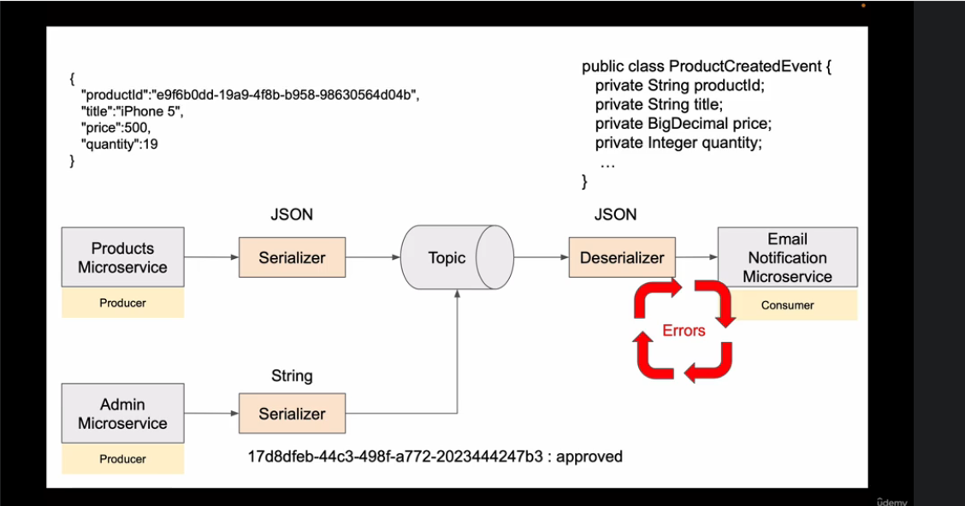

WE SHOULD USE ERROR HANDLING DESERIALIZER CLASS SO THAT IF IN TOPIC SOME OTHER EVENT COMES WHICH DOES NOT FIT THE STRUCTURE THAT THE CONSUMER IS CONSUMING THEN IT SHOULD HANDLE IT (SKIP) INSTEAD OF THROWING ERROR
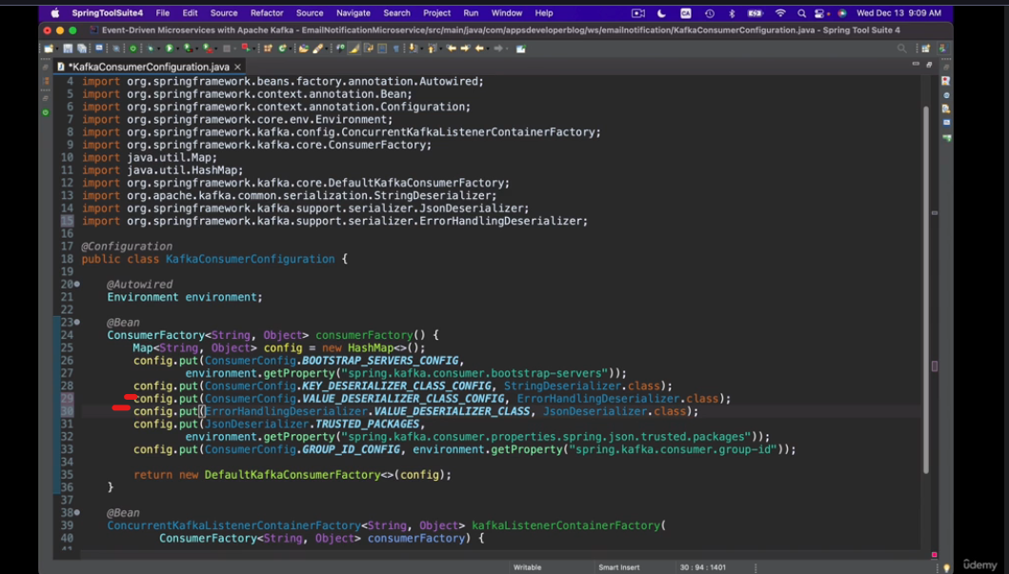
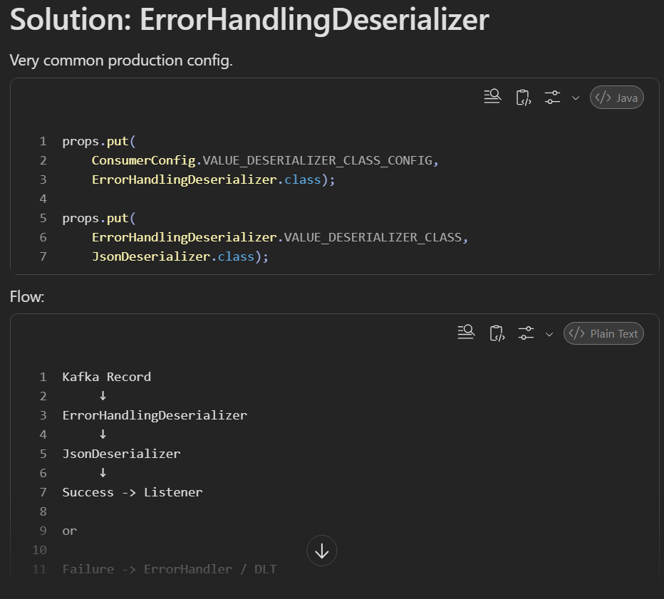
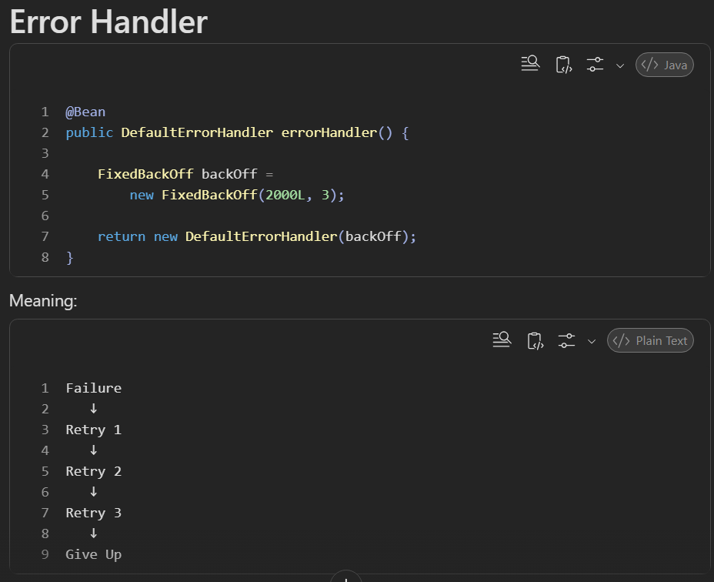
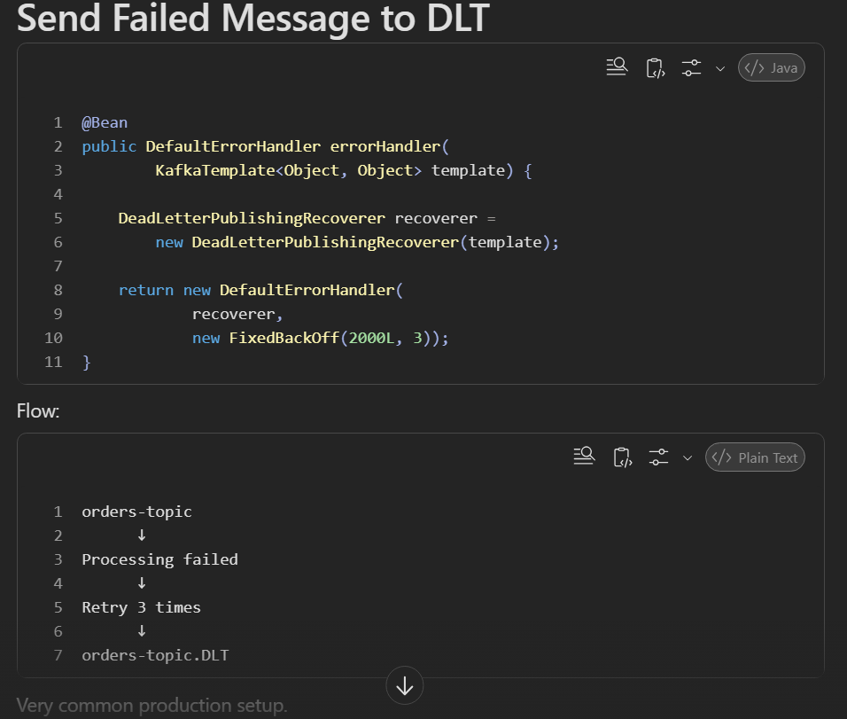
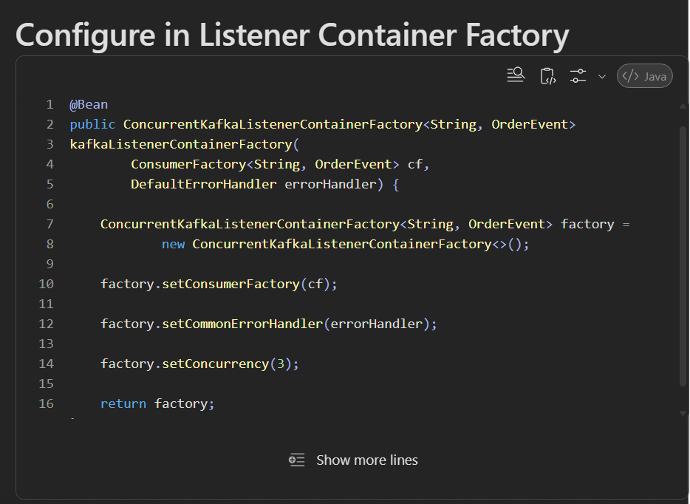

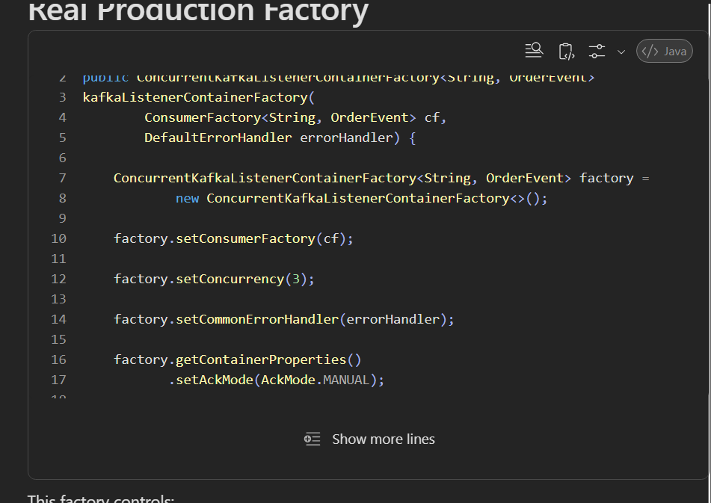
✓ Number of consumers (concurrency)
✓ Retry
✓ Backoff
✓ DLT
✓ Manual Ack
✓ Error Handling
✓ Deserialization behaviour
✓ Batch processing

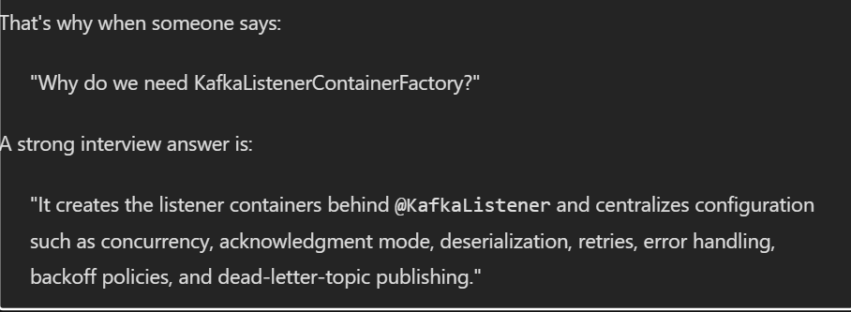
DLT (DEAD LETTER TOPIC) 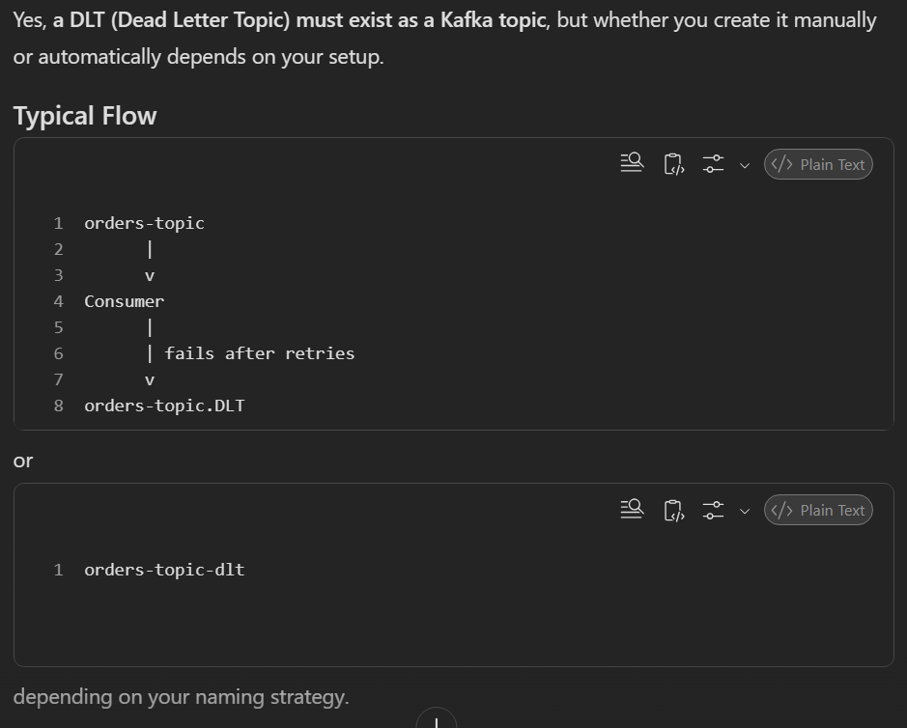
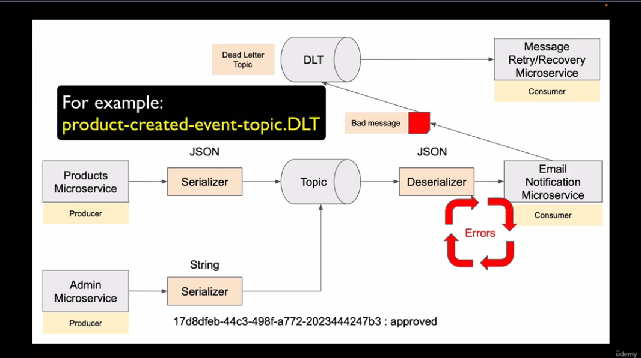

A Dead Letter Topic is a separate Kafka topic where messages are sent after retry attempts are exhausted.
In production, DLT topics are usually created manually by infrastructure teams with the appropriate partition count and replication factor.
Spring Kafka can automatically publish failed records to the DLT using DeadLetterPublishingRecoverer and DefaultErrorHandler. A common naming convention is <topic>-dlt or <topic>.DLT.
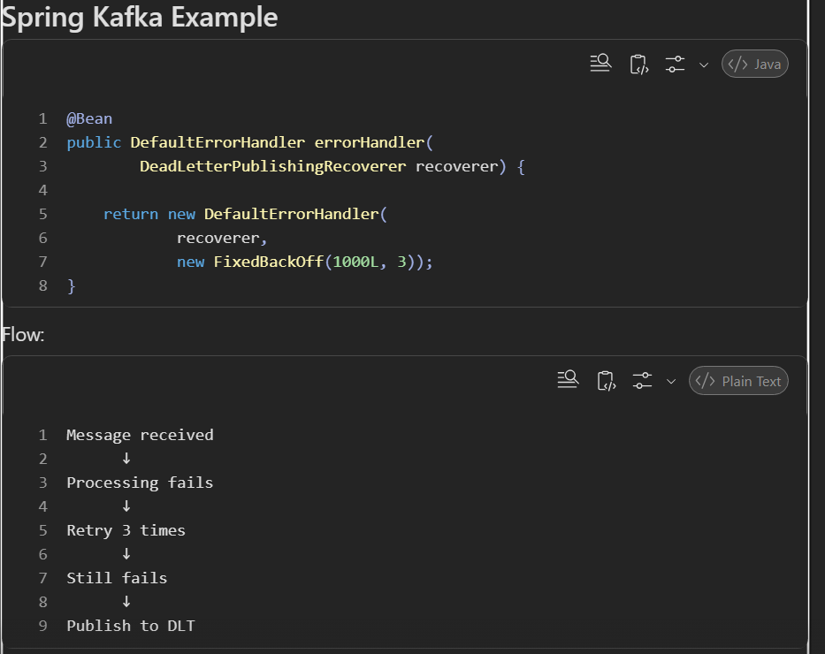
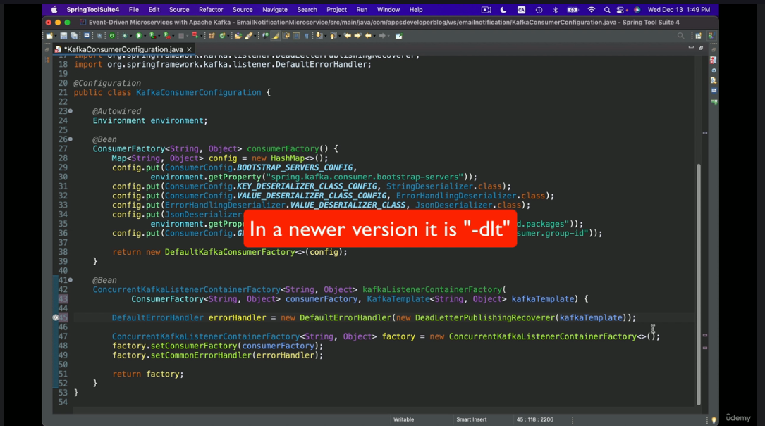
ADD KAFKA TEMPLATE & PRODUCER FACTORY BEAN FOR THE DEAD LETTER PUBLISHING RECOVERER
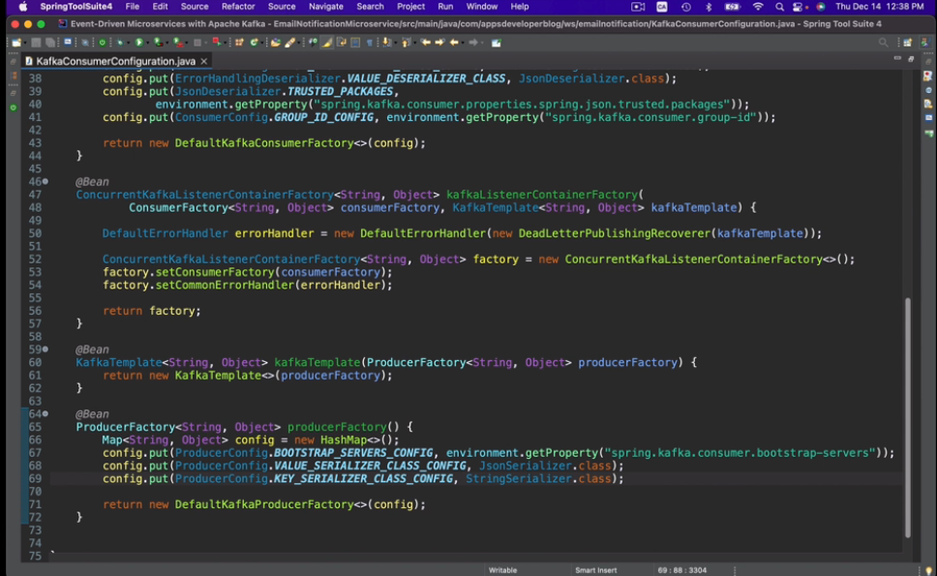
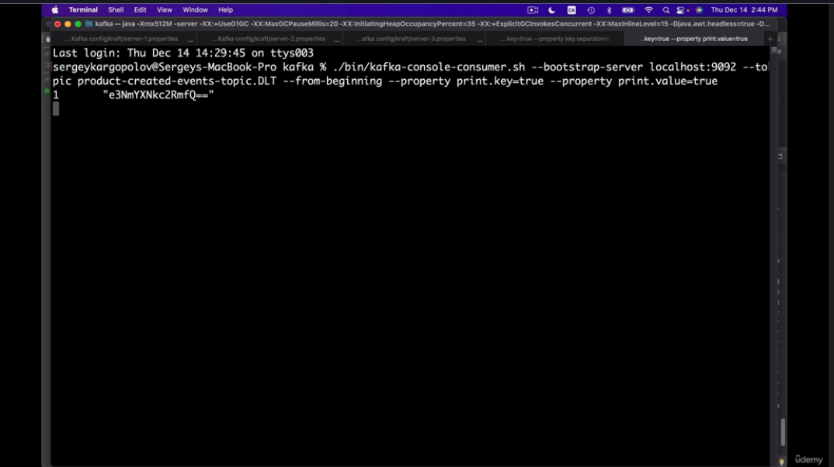

KAFKA CONSUMER EXCEPTION & RETRIES:
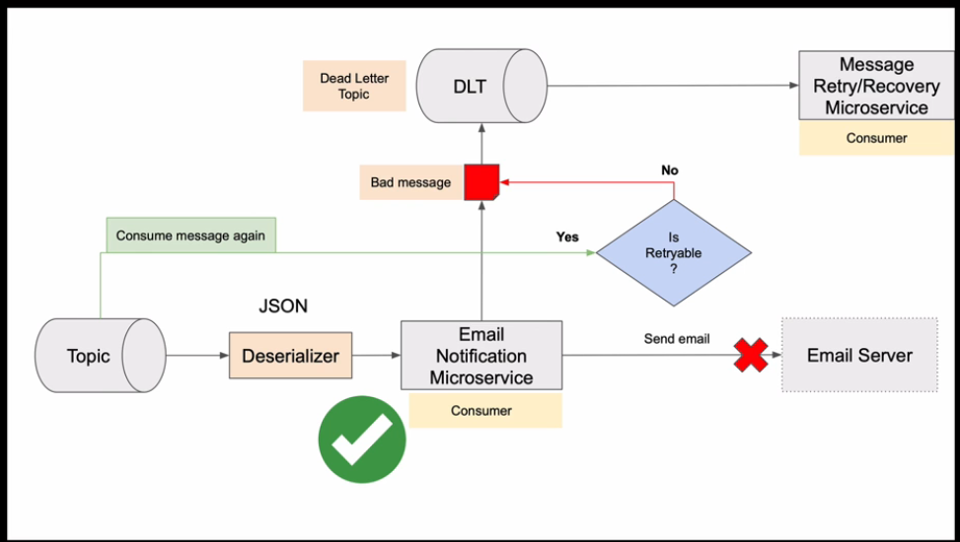
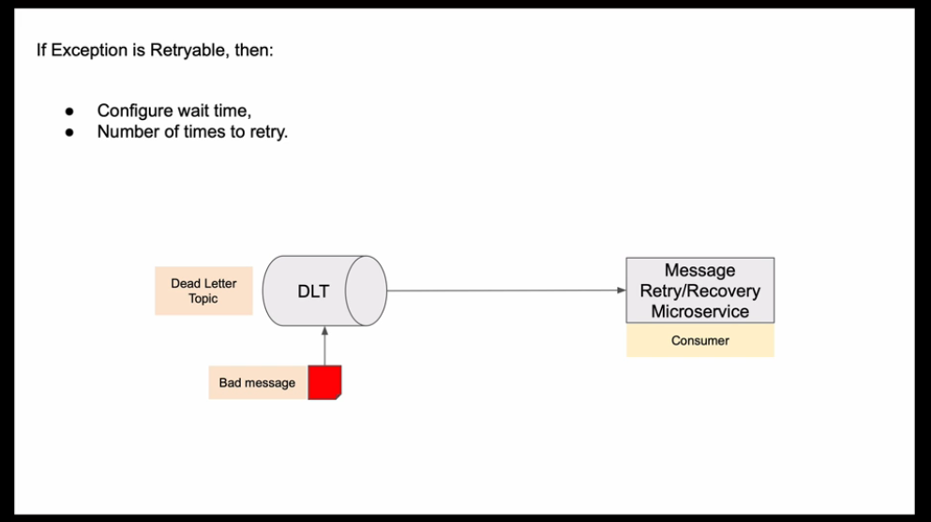

Handling Non-Retryable exception or Retryable exception
We can add extra addNoRetryableException by [ , ] separator
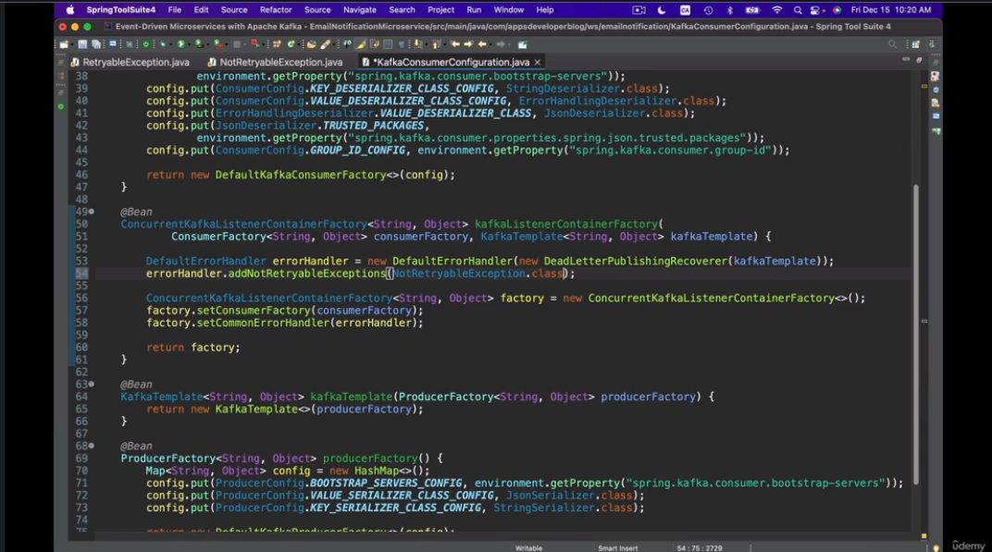
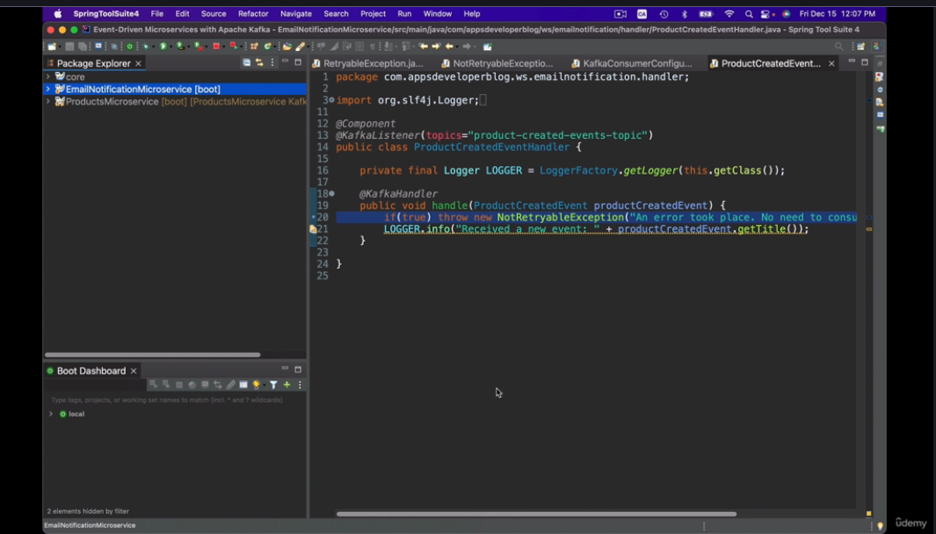

RETRYABLE EXCEPTION:
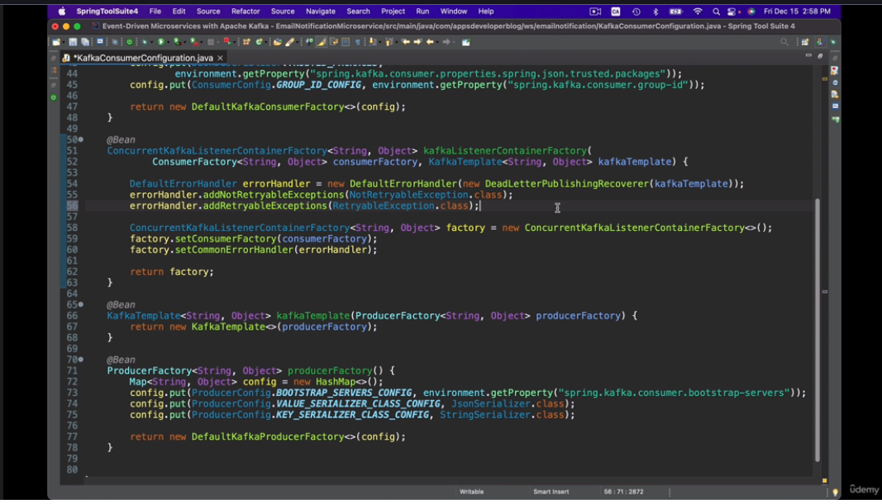
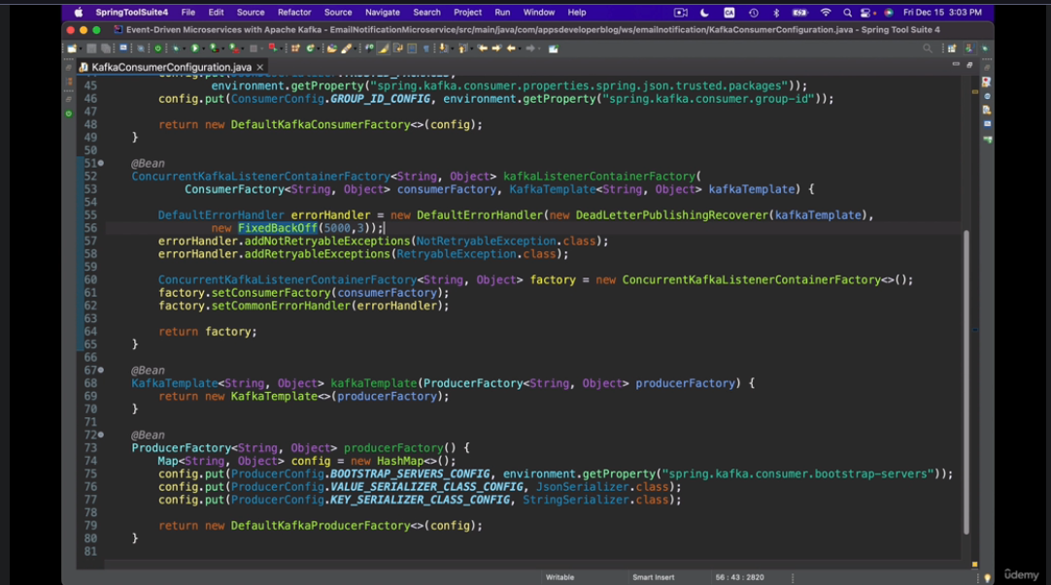

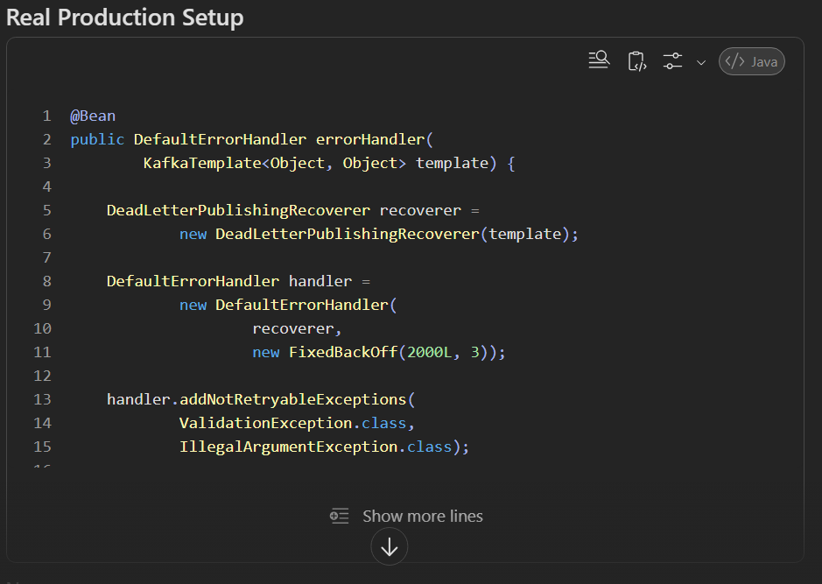
EXPONENTIAL BACKOFF WITH RETRIES
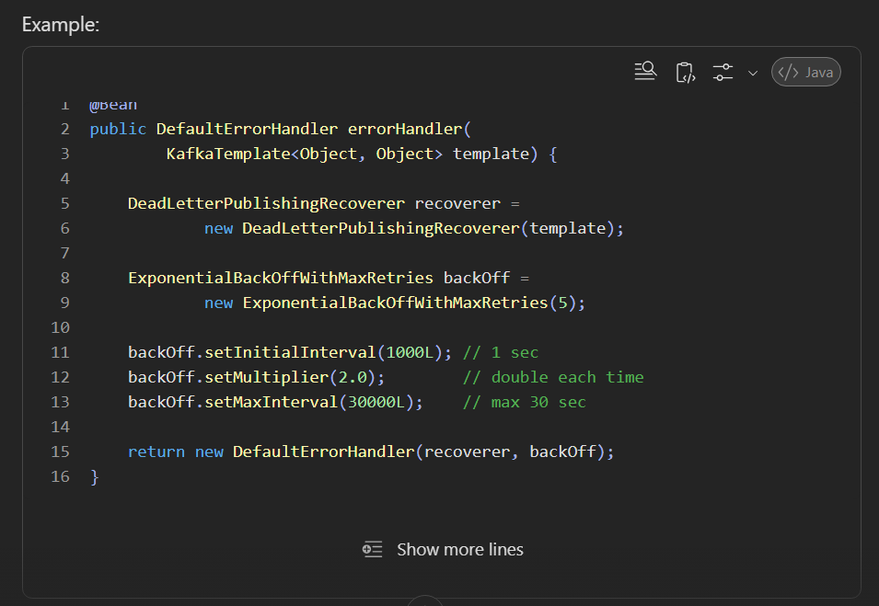
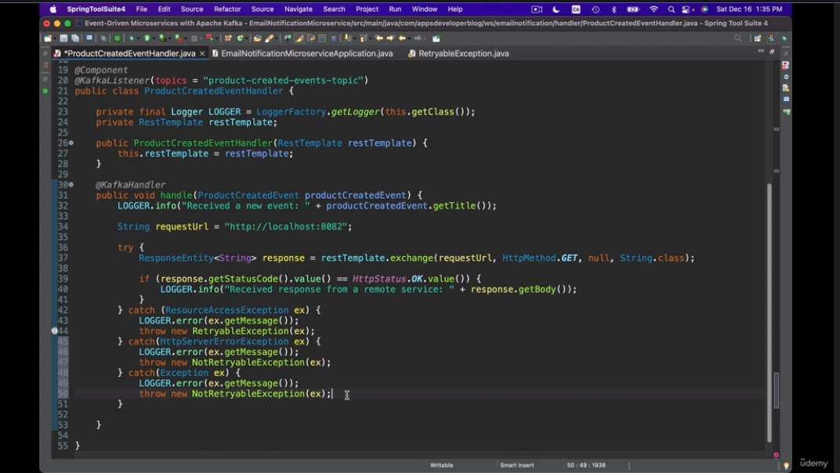
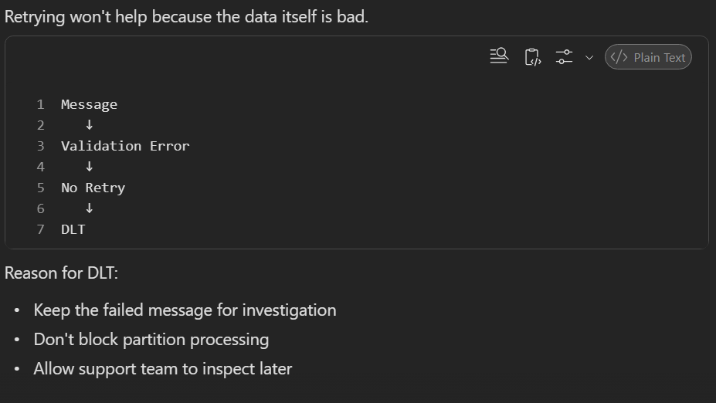
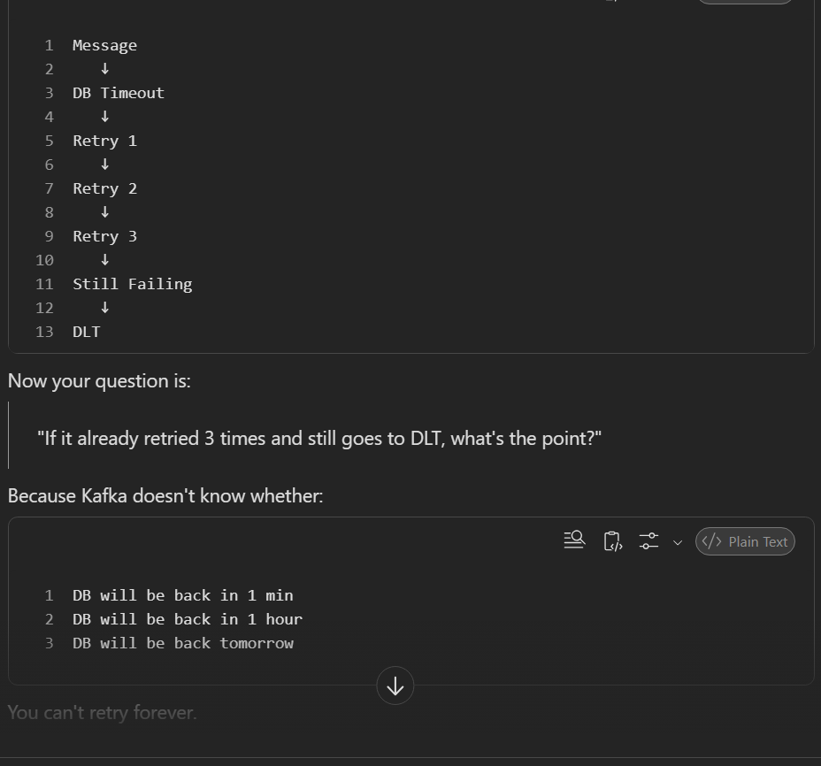

DEBUGGING:::
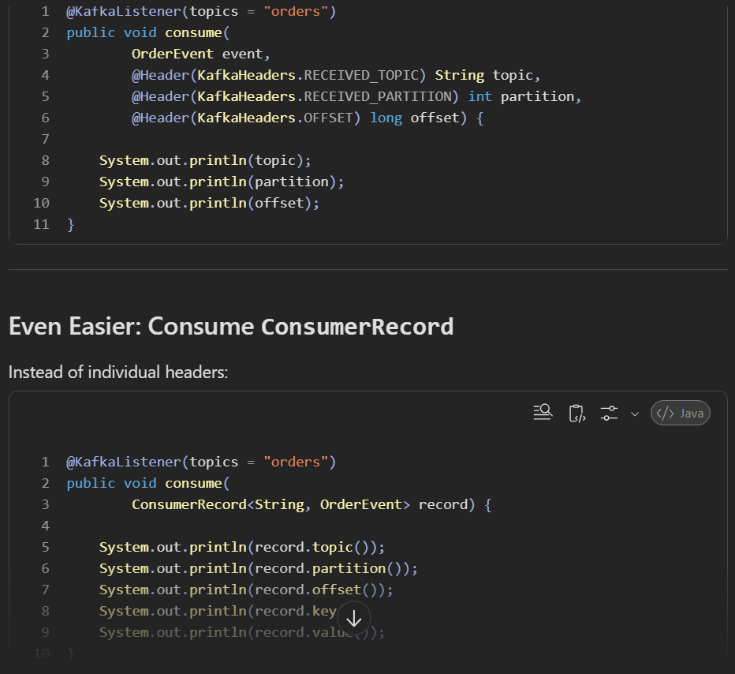

CONSUMER GROUP::
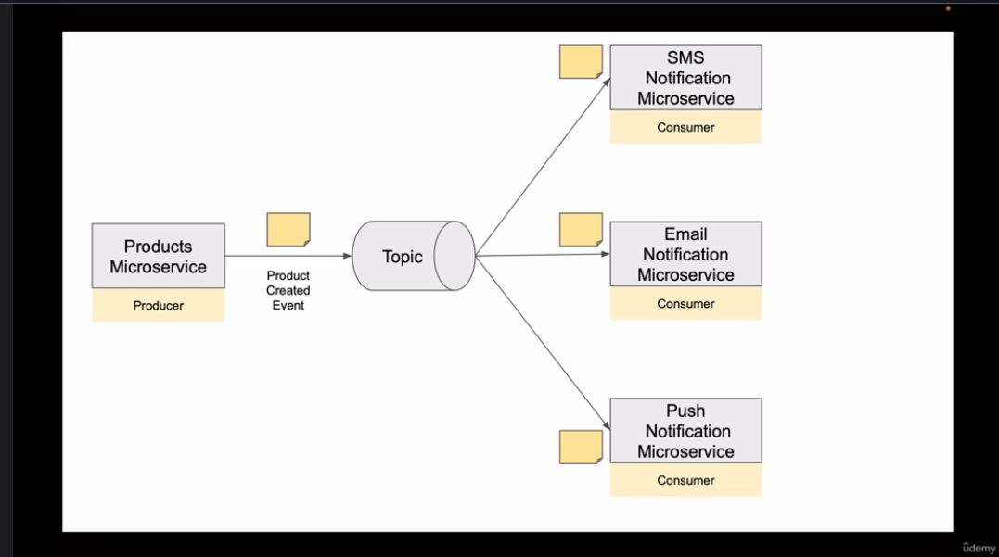
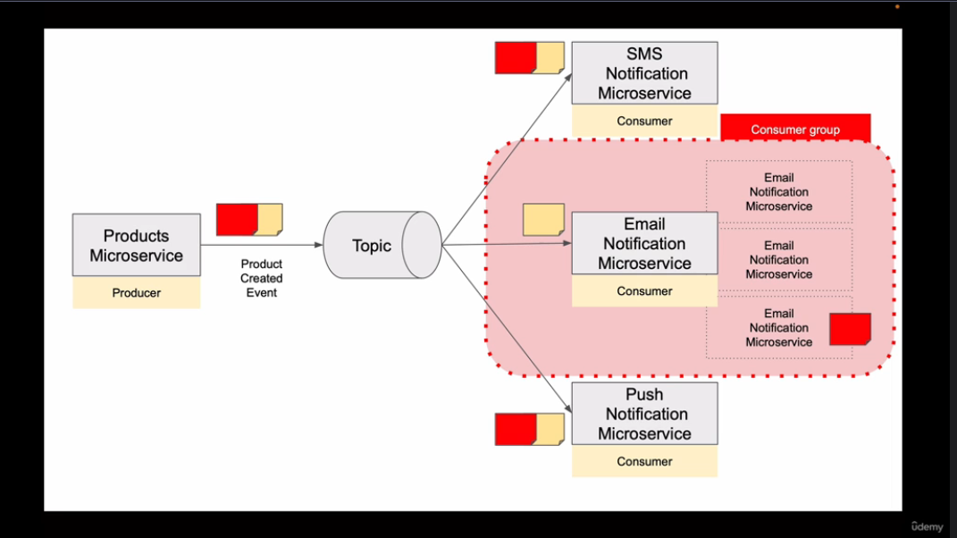

REBALANCING & PARTITION ASSIGNMENT IN APACHE KAFKA
If we have only one consumer instance. All partitions will come to one consumer.
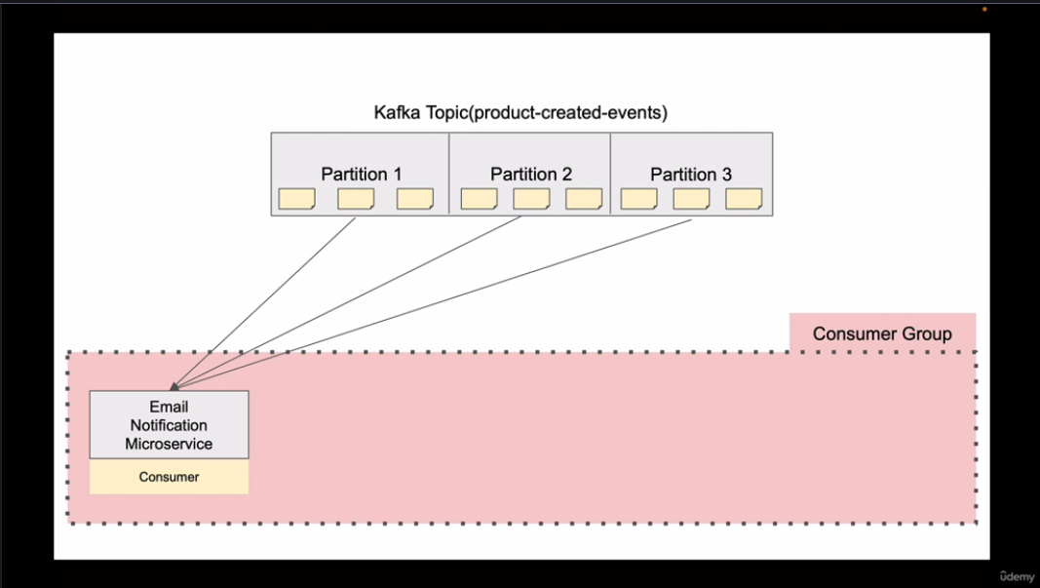
If you need to scale out then Kafka reassign the partitions among the consumer instances. While re-assigning consumer stop consuming messages for a moment
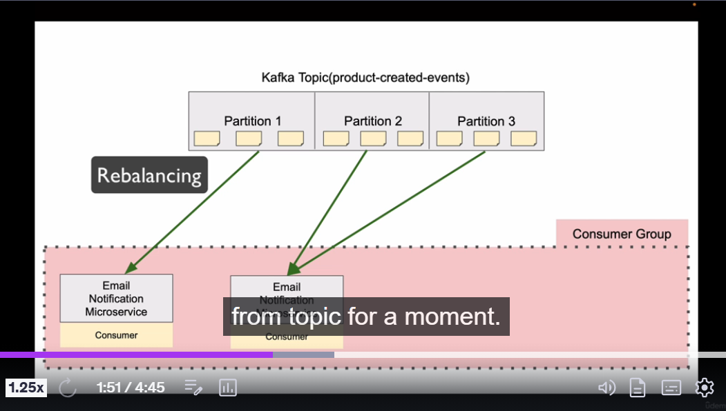
Rebalancing happens like one consumer is added or removed or even if partitions are added.

If you have more consumer then it will remain idle we cannot assign one partition to more than on consumer
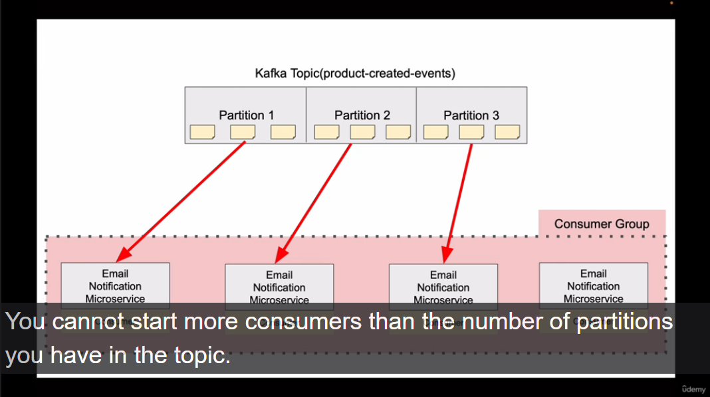

Consumer sends heart beats to broker session.timeout.ms (default its 3sec)
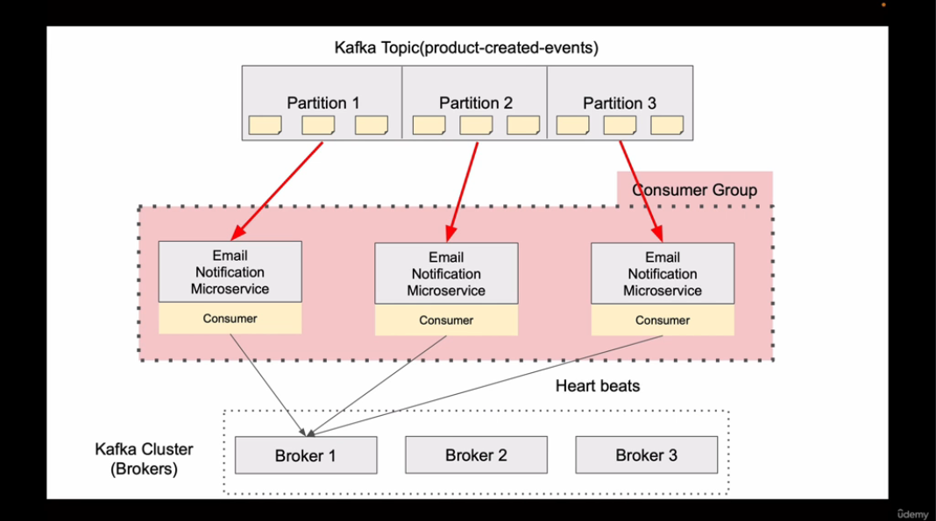

If no heartbeats are coming from the consumer, then the partition Is rebalanced to one of the healthier consumers
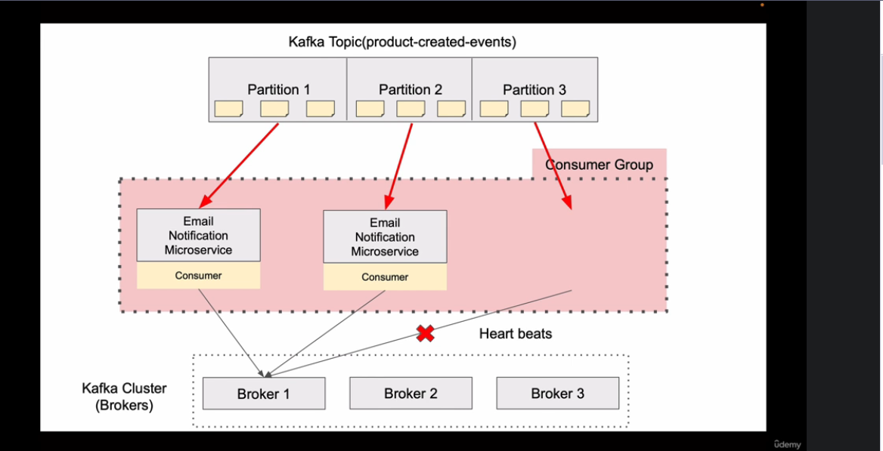
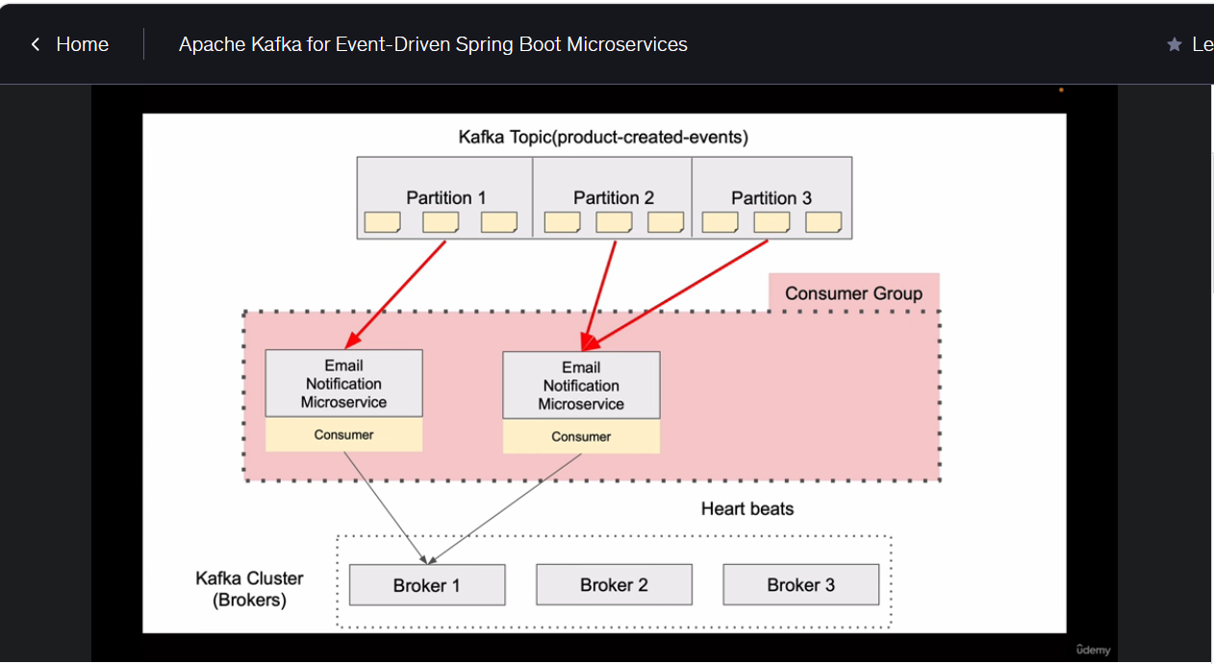

You can configure the group-id in either @KafkaListener or in mention it in the consumer-config.
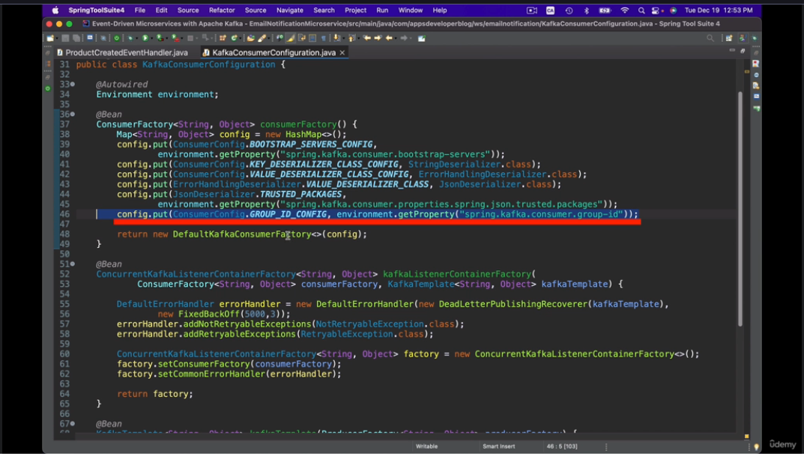
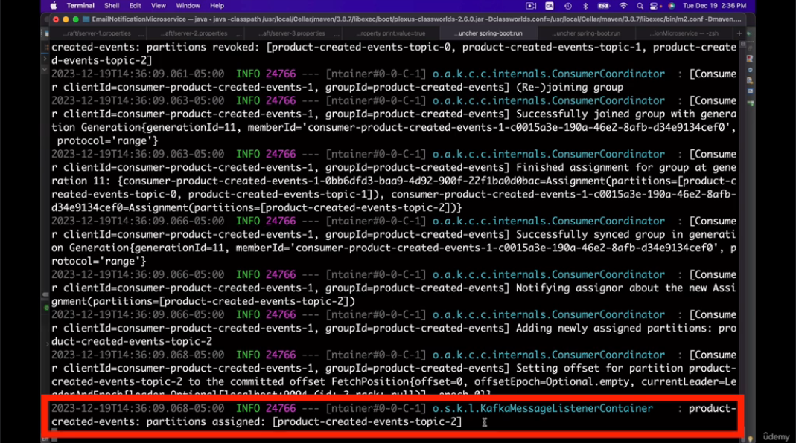
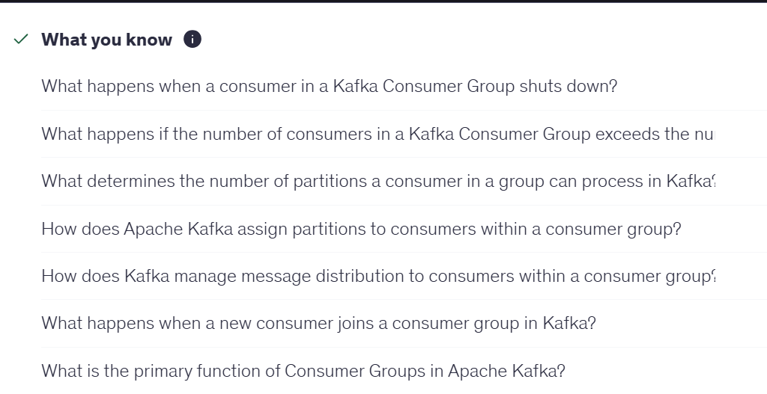

IDOMPETENT CONSUMER:
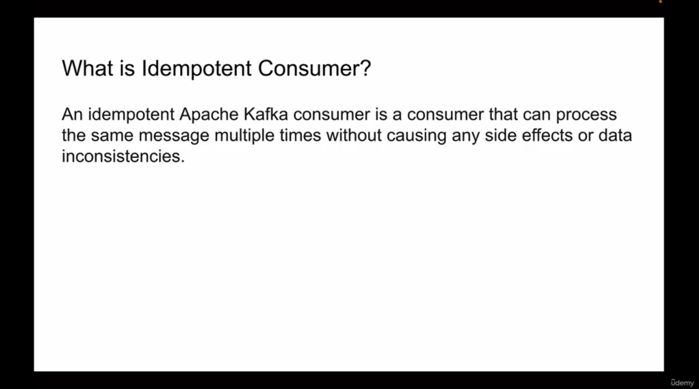

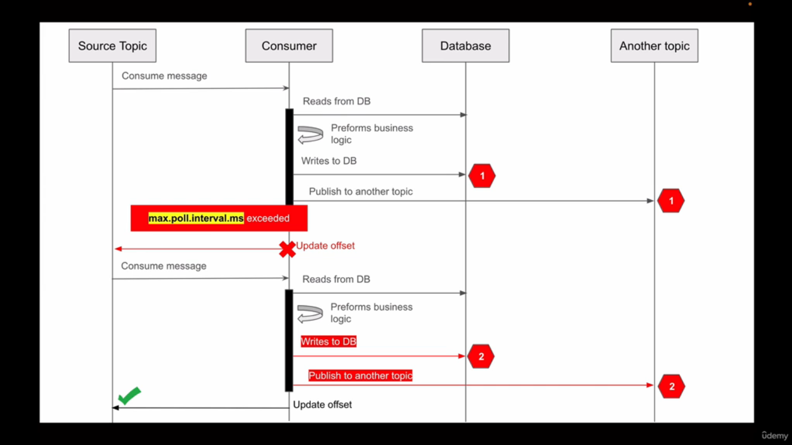

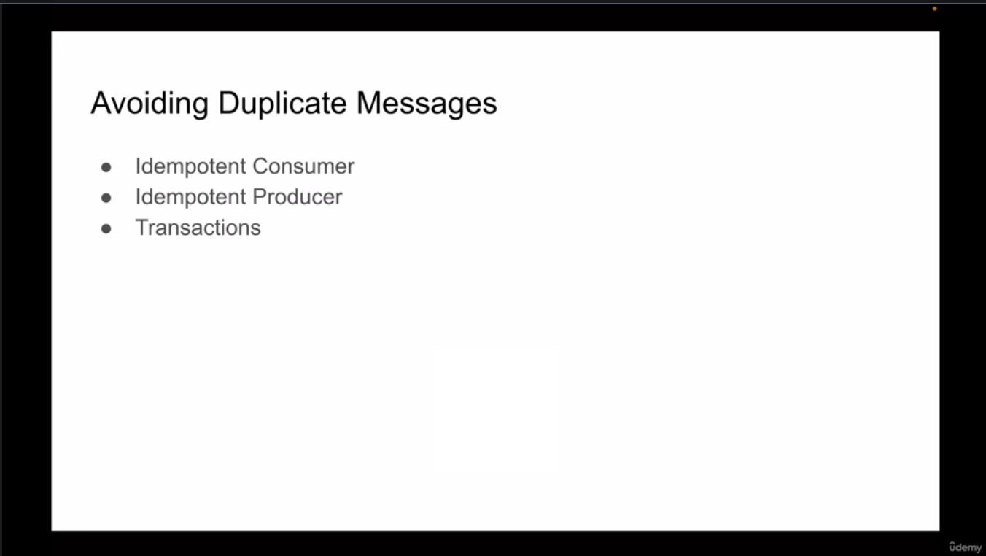
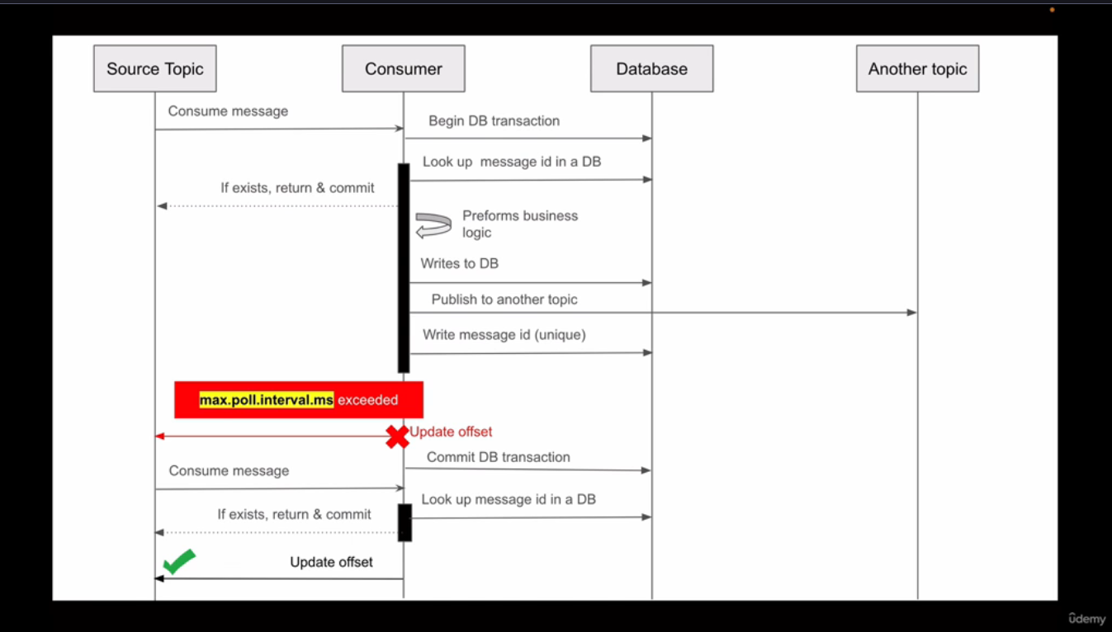
max.poll.interval.ms specifies the maximum delay allowed between two poll() calls. If a consumer does not call poll() within this interval, Kafka considers it unable to make progress, removes it from the consumer group, and triggers a rebalance. It prevents consumers from holding partitions indefinitely while being stuck processing records.
Session.timeout.ms = Is the consumer alive?
max.poll.interval.ms = Is the consumer still doing work and polling?

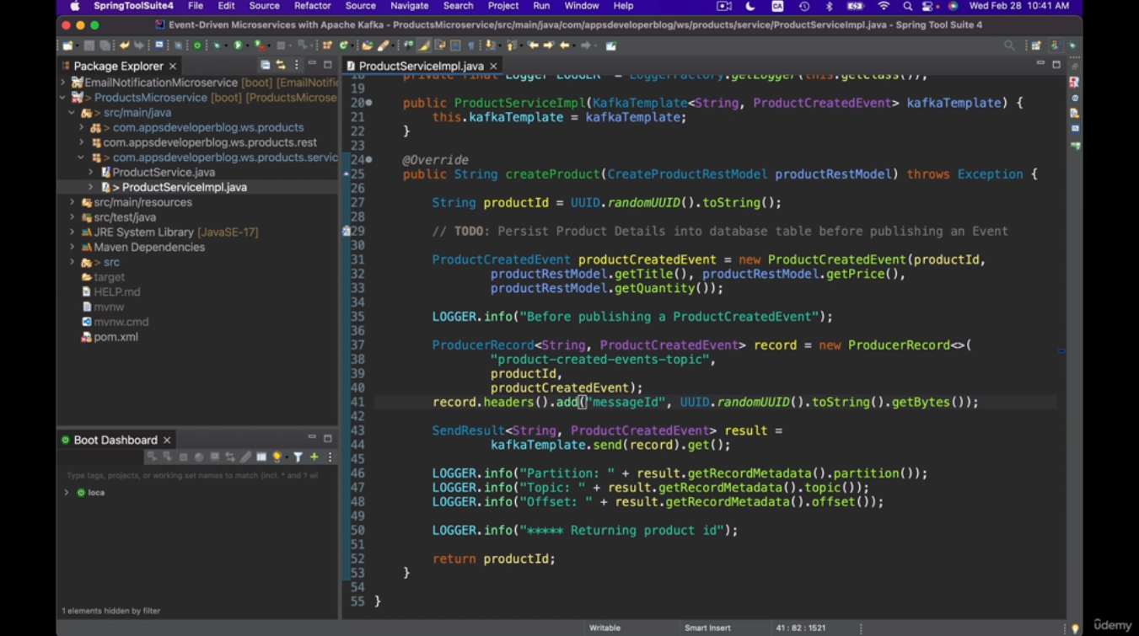

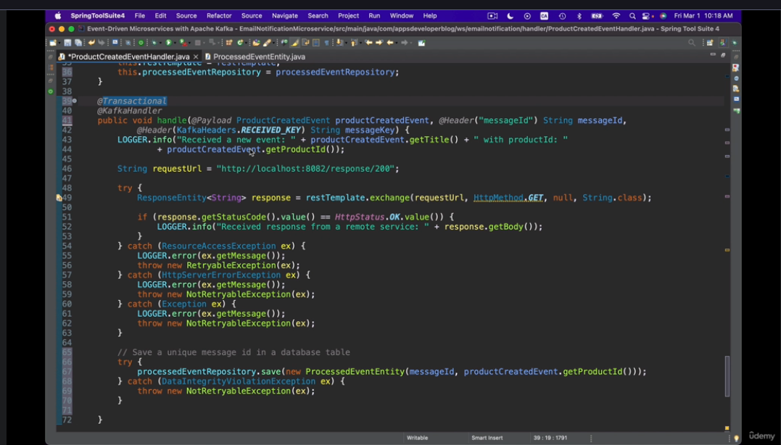

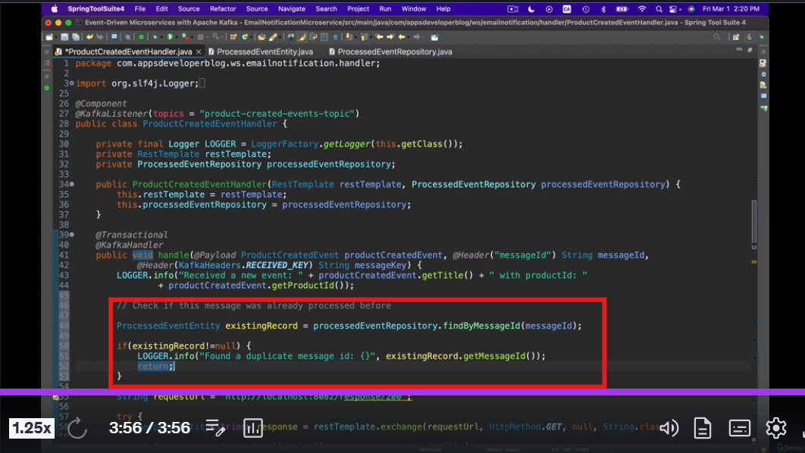

APACHE KAFKA TRANSACTIONS:
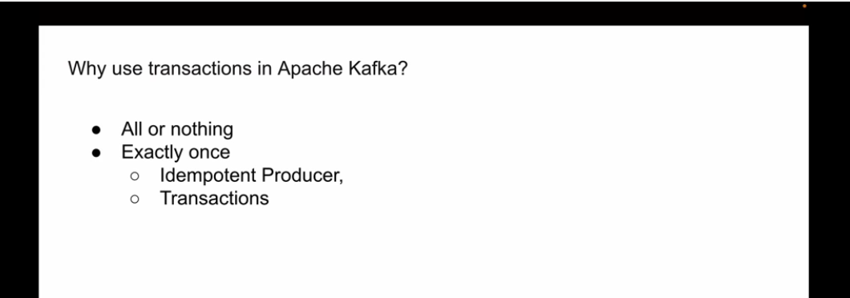

WITHOUT TRANSACTION:
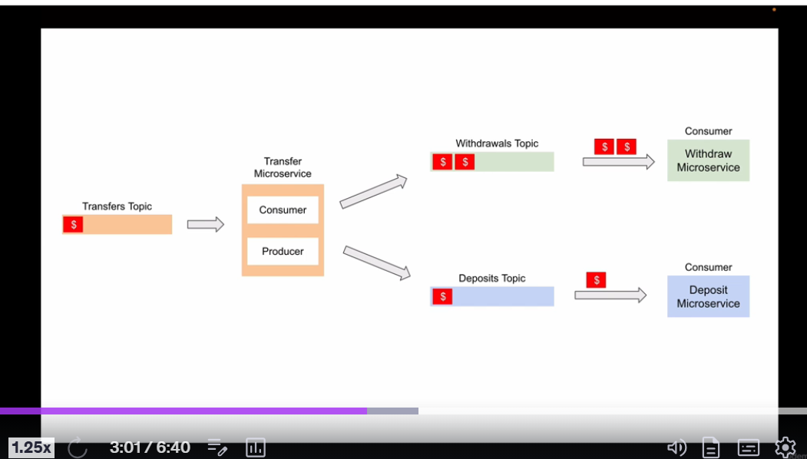
WITH TRANSACTION:
In this we have producer that produces an event then, It is consumed by Transfer Microservice then the same microservice should produce the event to the withdraw topic and the deposit topic.
so we have something called read uncommitted and then committed then which helps use to make an environment which says either do all or nothing
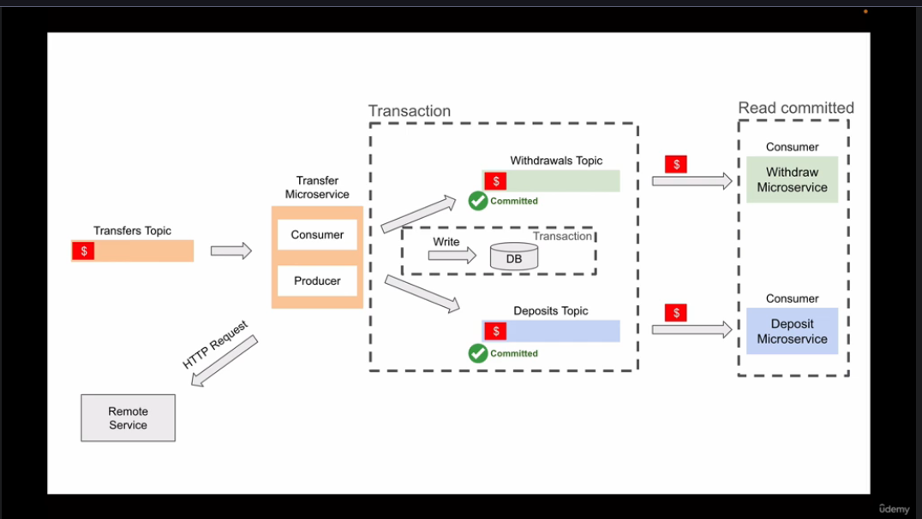

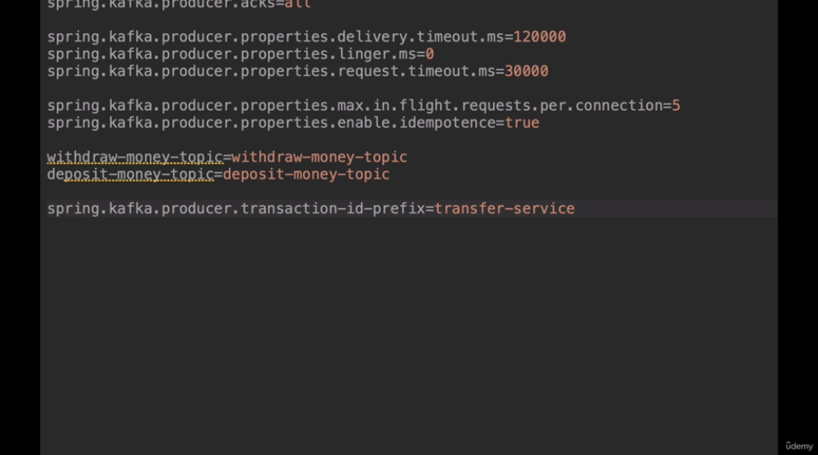
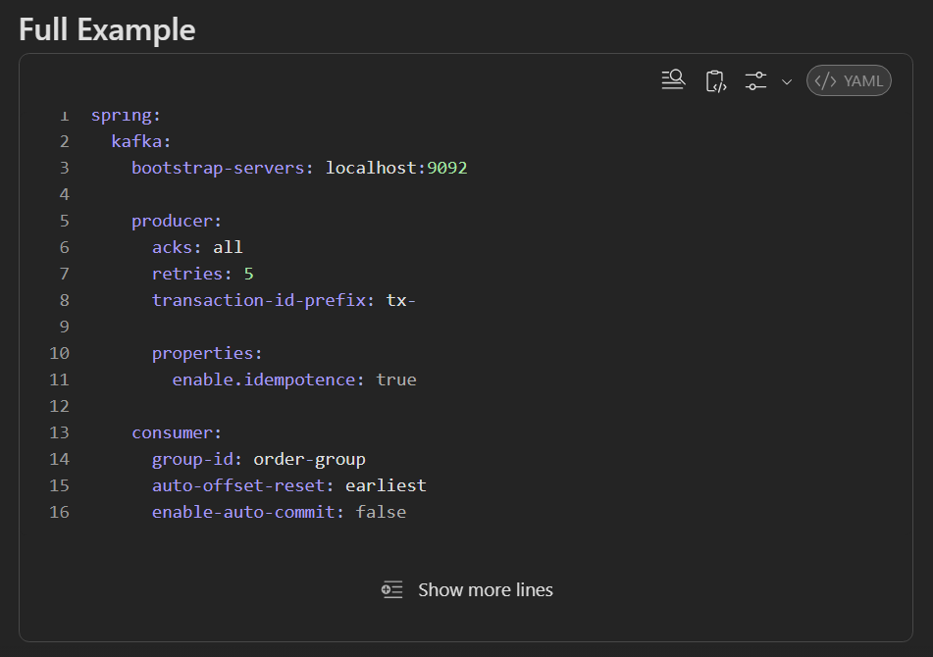
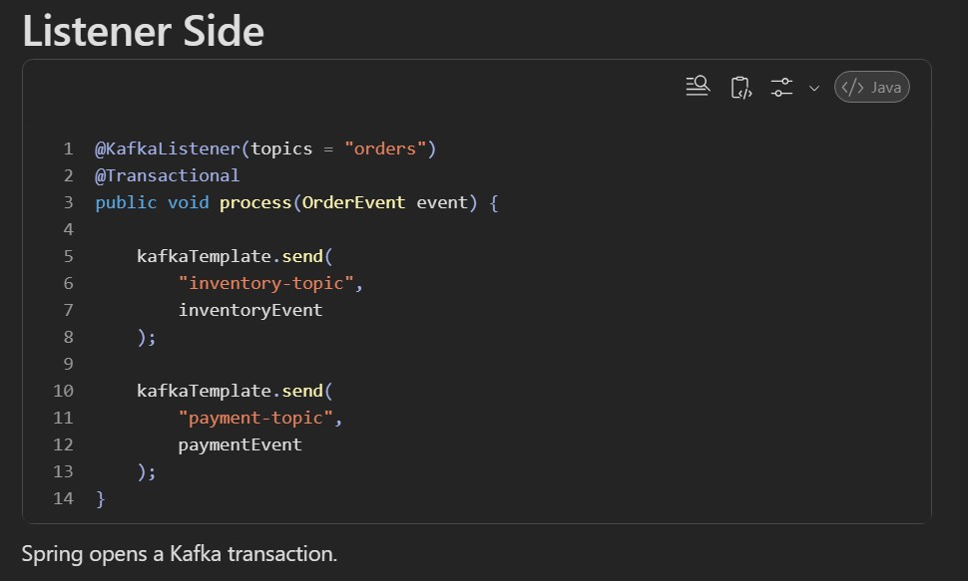
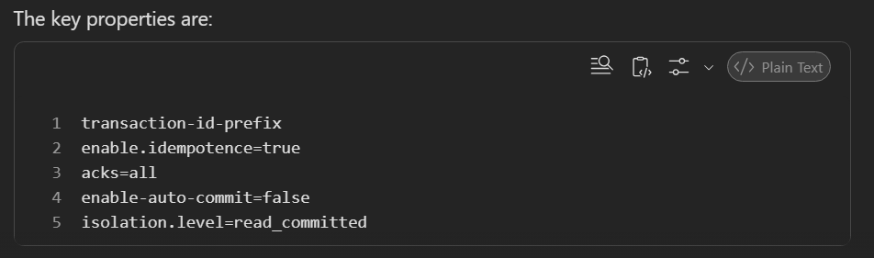
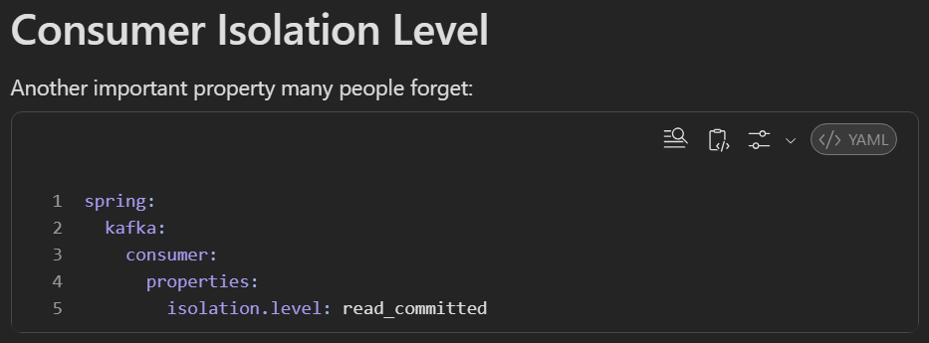

If you run multiple instances of the service running use this ${random.value}
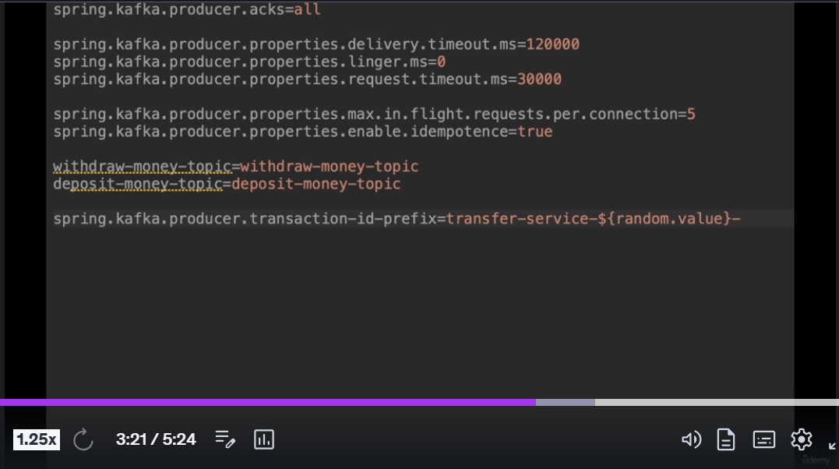

Use java bean config for kafka transactions
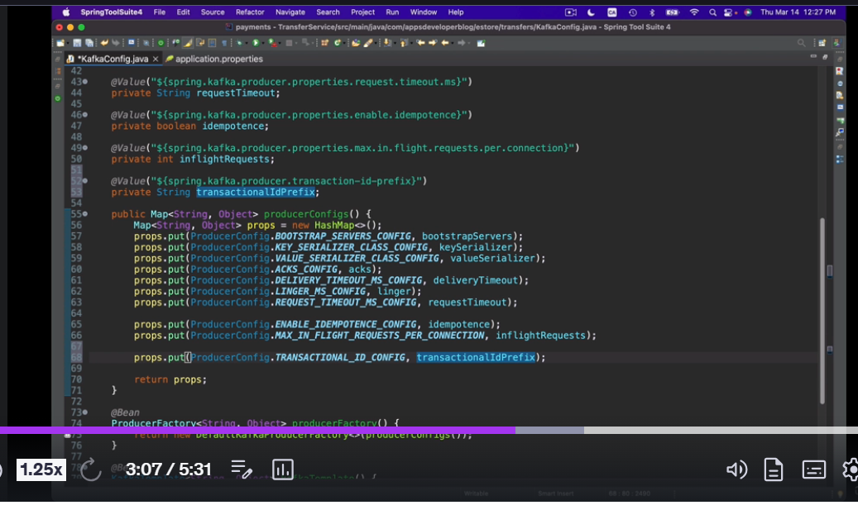

Create a bean for the Kafka Transactional Manager
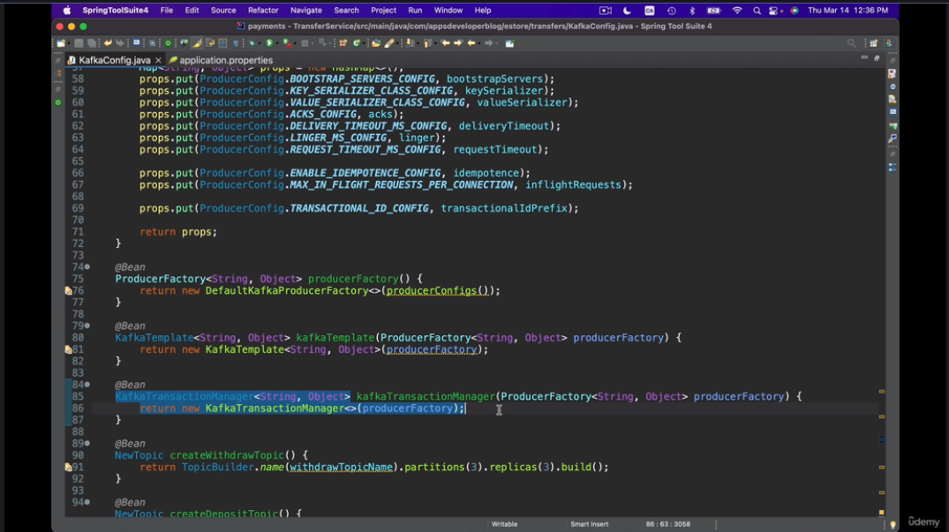
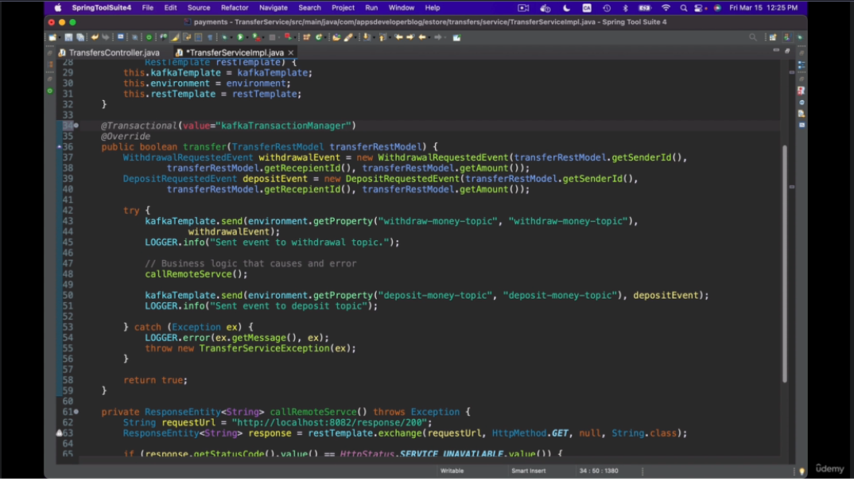
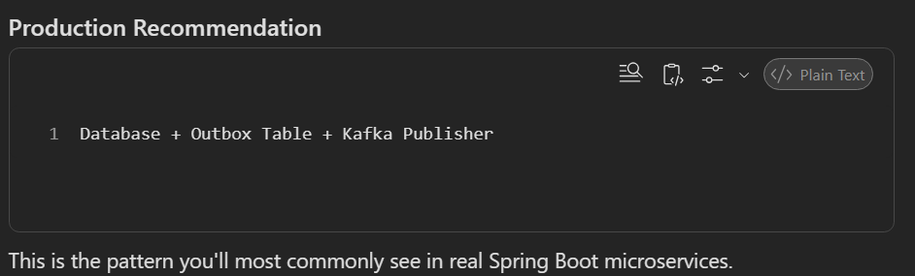
This is as usual transactional annotation behaves only for unchecked and erro
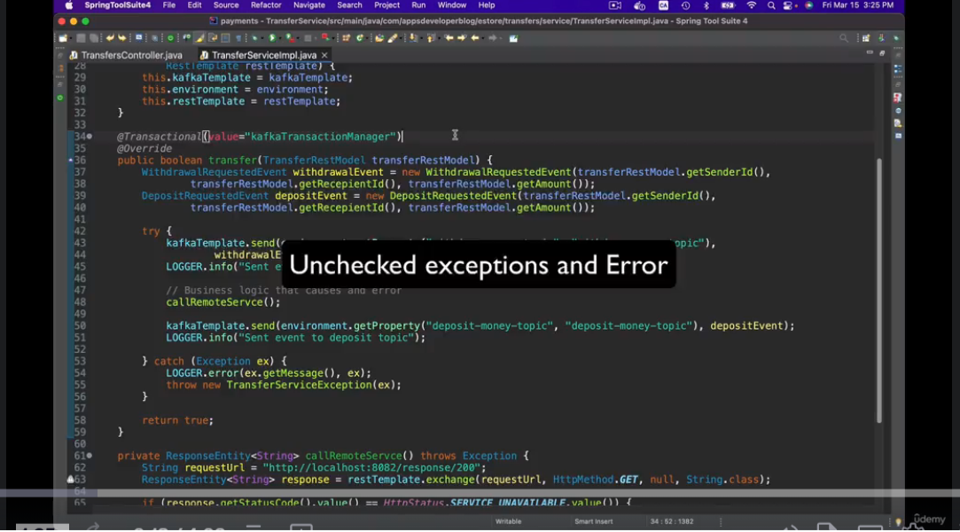
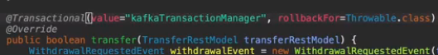
Can provide more than one exception by { , , … }
We also have no rollback for as well forn the exception we don’t need to rollback
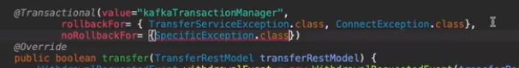

Default value In the consumer service is read uncommitted, but if we need the kafka transactions to work properly then we should set the value as read_committed
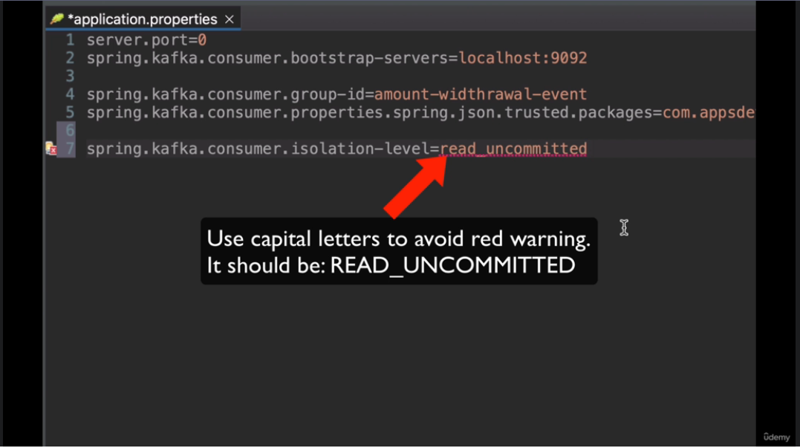
Bean config for the consumer isolation level….
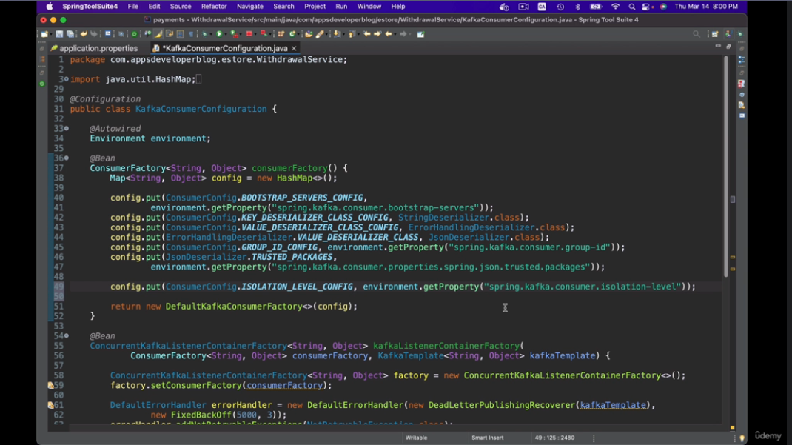

KAFKA TEMPLATE -> executeInTransaction
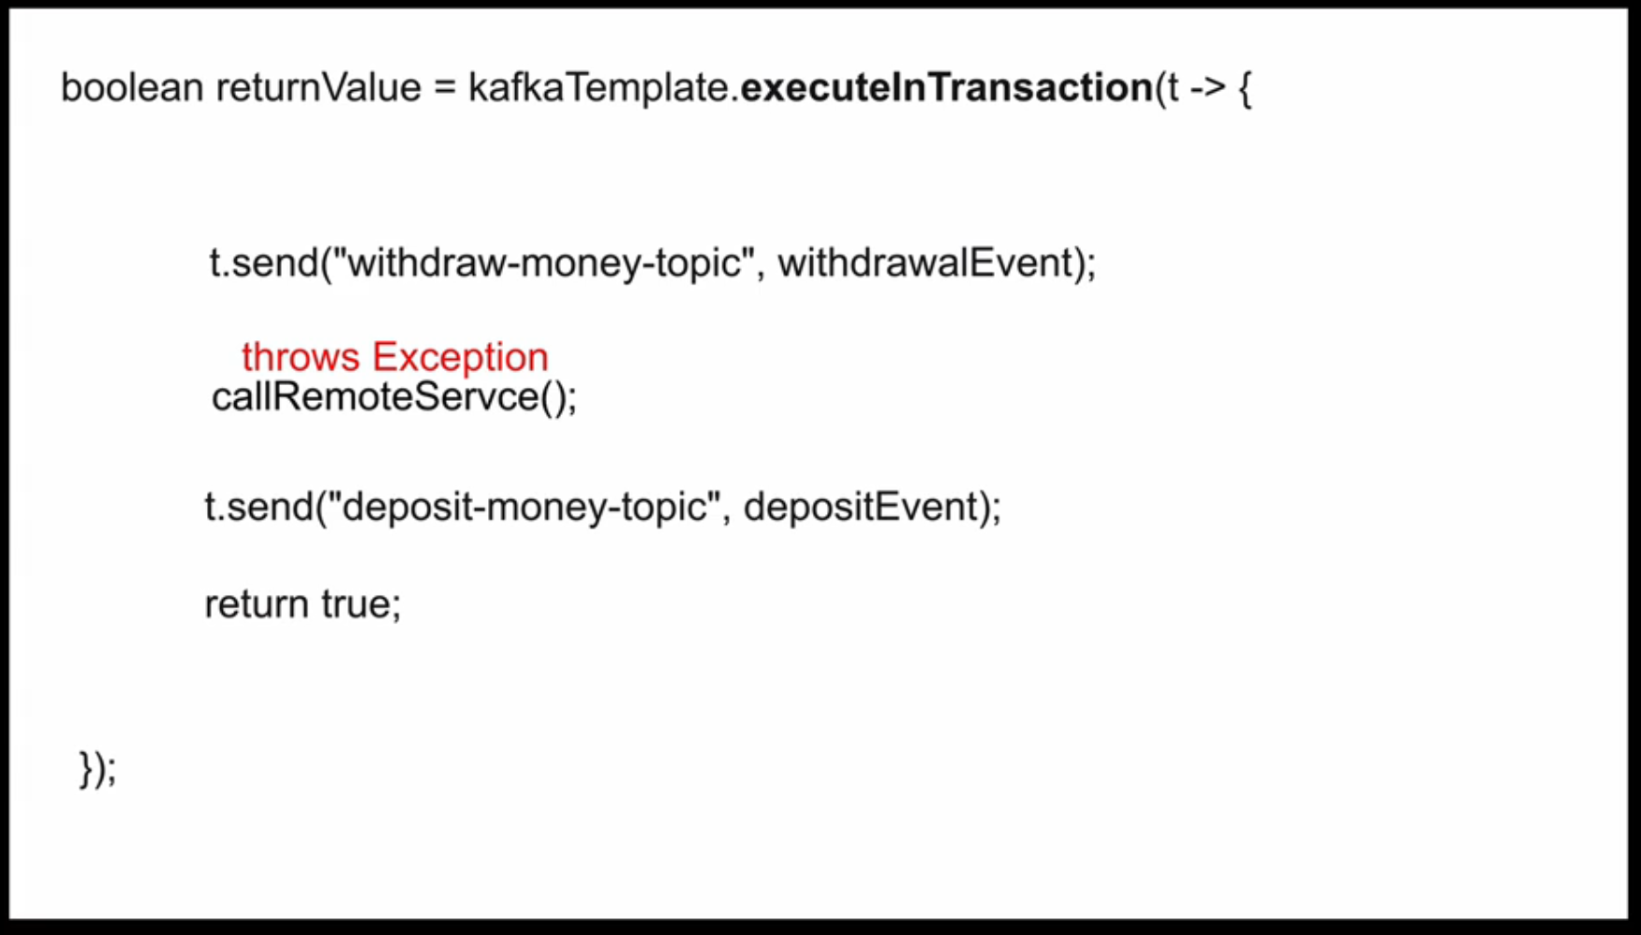
Feature | executeInTransaction() | @Transactional("kafkaTransactionManager")
Purpose | Transaction around a block of Kafka sends | Transaction around an entire method
Who starts transaction? | KafkaTemplate | Spring Transaction Manager
Producer sends atomic? | ✅ Yes | ✅ Yes
Works with @KafkaListener? | ❌ Not directly | ✅ Yes
Can include consumer offset commits? | ❌ No | ✅ Yes
Consume → Process → Produce flow | ❌ Not ideal | ✅ Main use case
Method rollback support | ❌ Only code inside callback | ✅ Whole method
Requires transaction-id-prefix? | ✅ Yes | ✅ Yes
Requires KafkaTransactionManager bean? | ❌ No explicit usage | ✅ Yes (Spring uses it)
Multiple topic writes atomically | ✅ Yes | ✅ Yes
Best for | Producer-only use cases | Consumer + Producer workflows

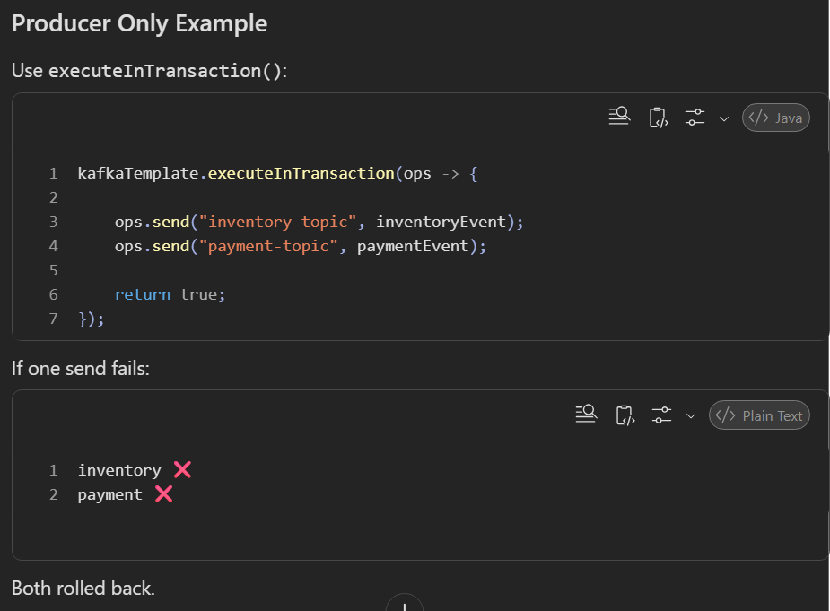

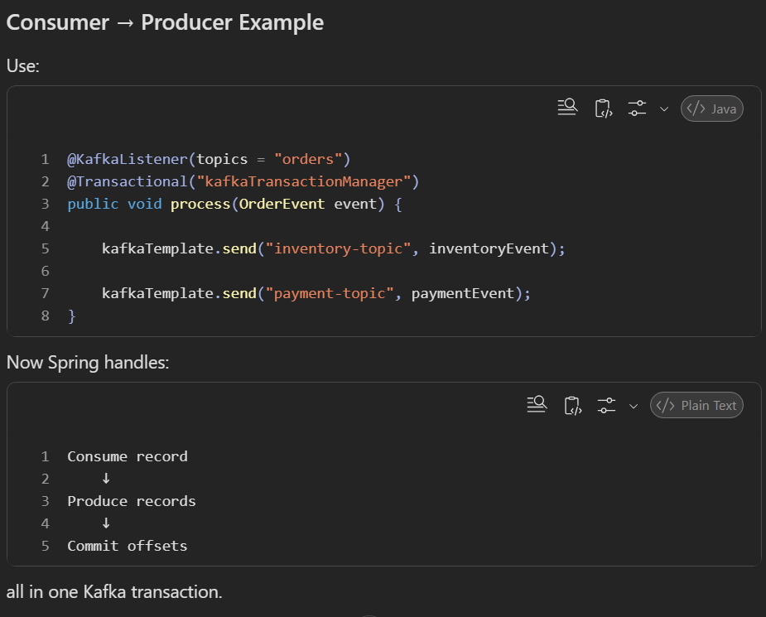

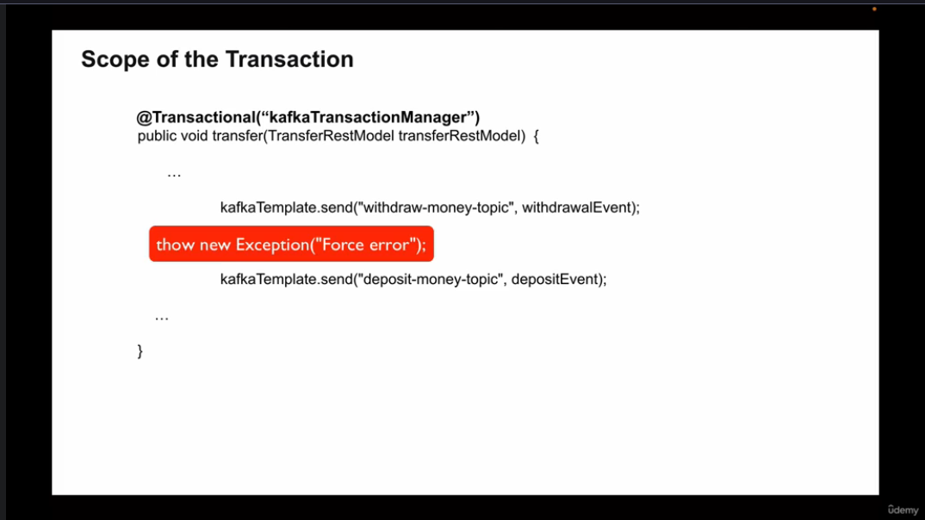

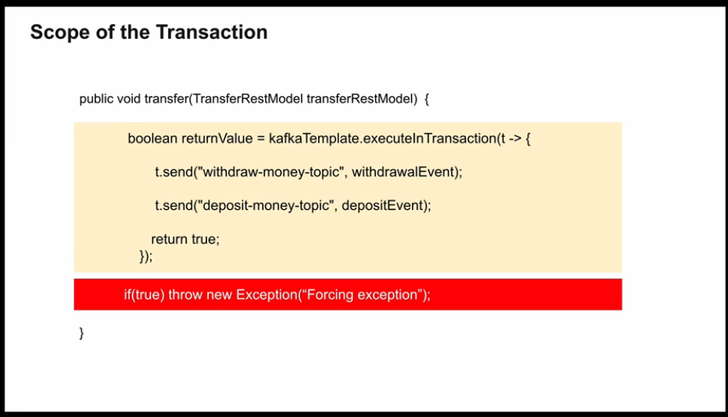
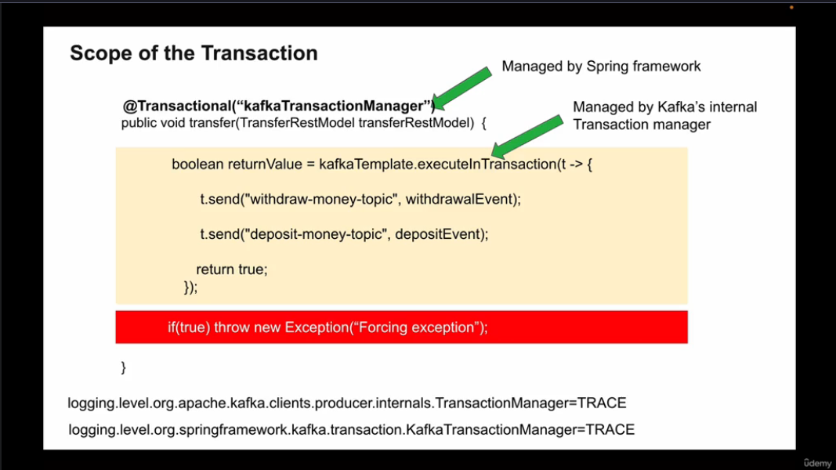

KAFKA & DATABASE TRANSACTIONS
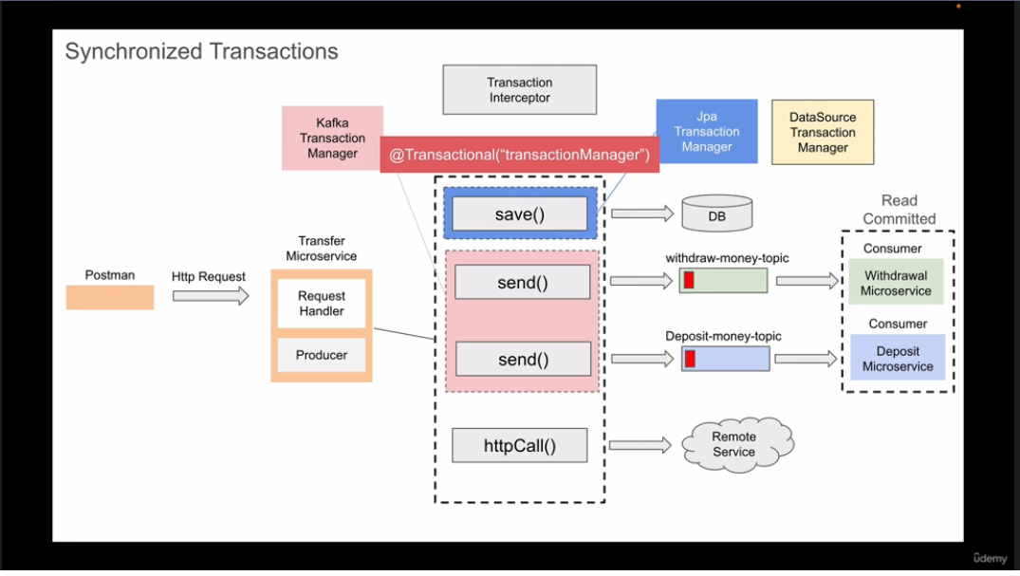
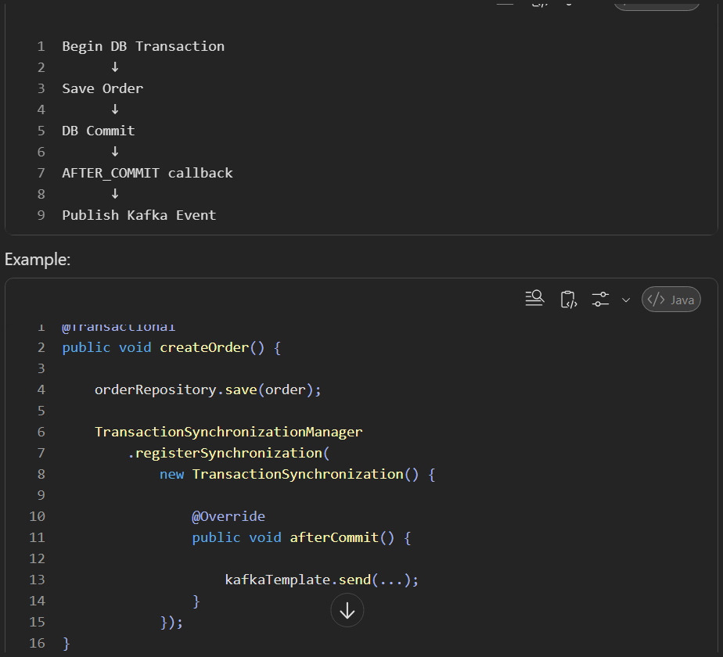
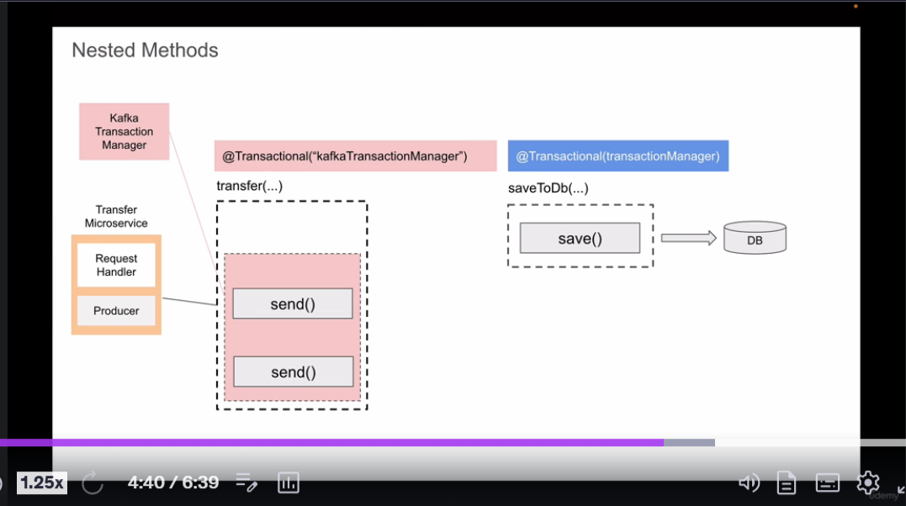
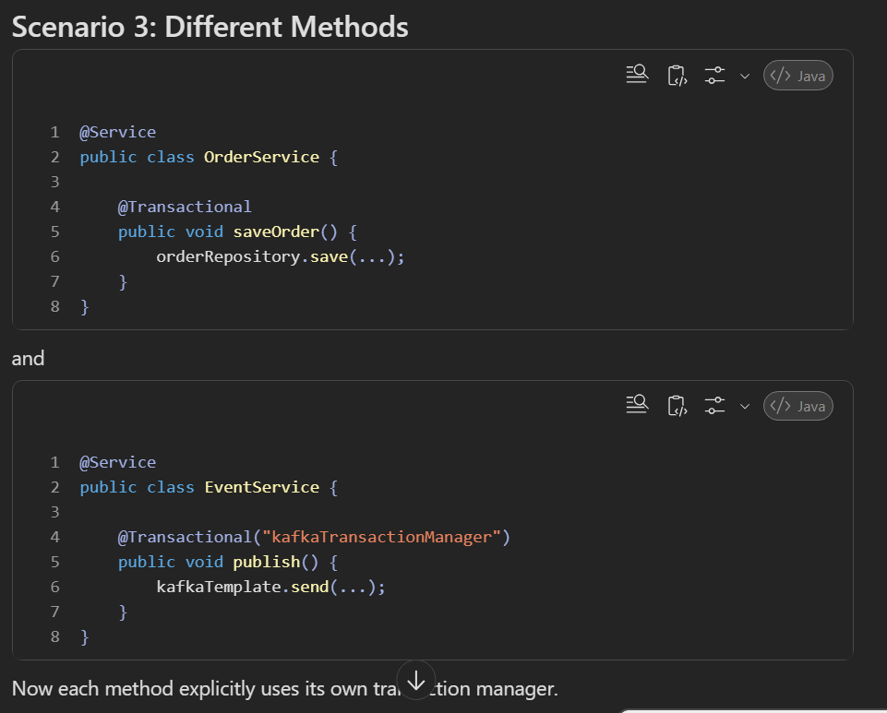

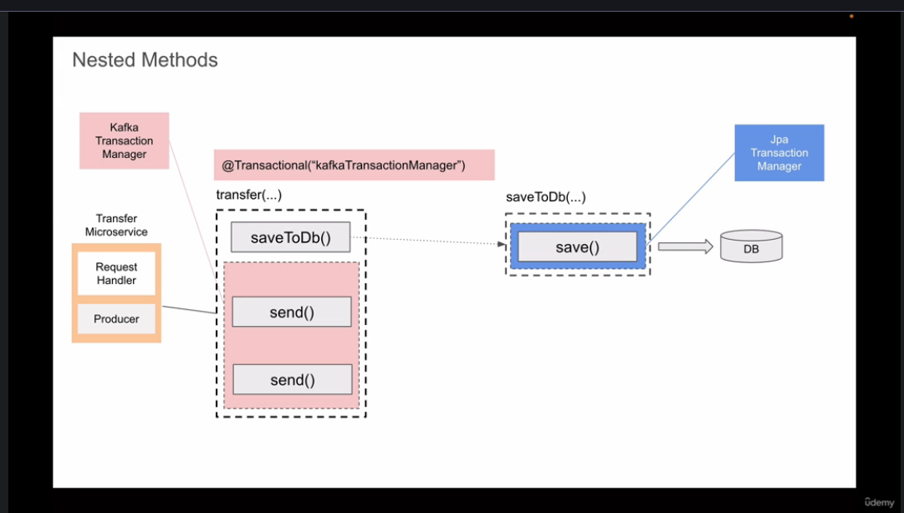
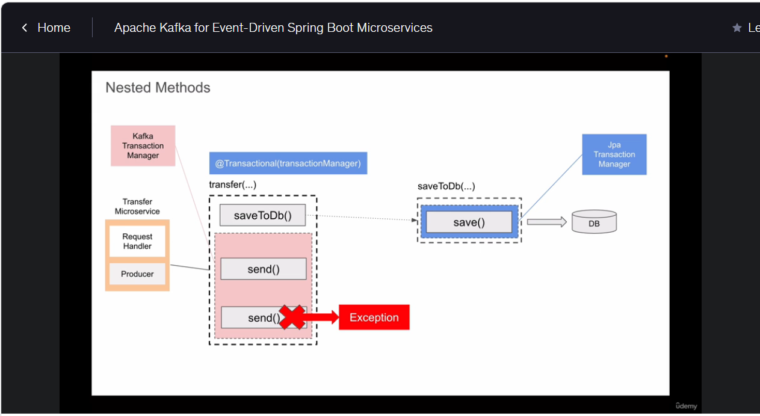

Spring by default uses the default transaction manager, which is typically JpaTransactionManager. To use Kafka transactions explicitly, I would use @Transactional("kafkaTransactionManager"). You can or don’t even need to create the bean
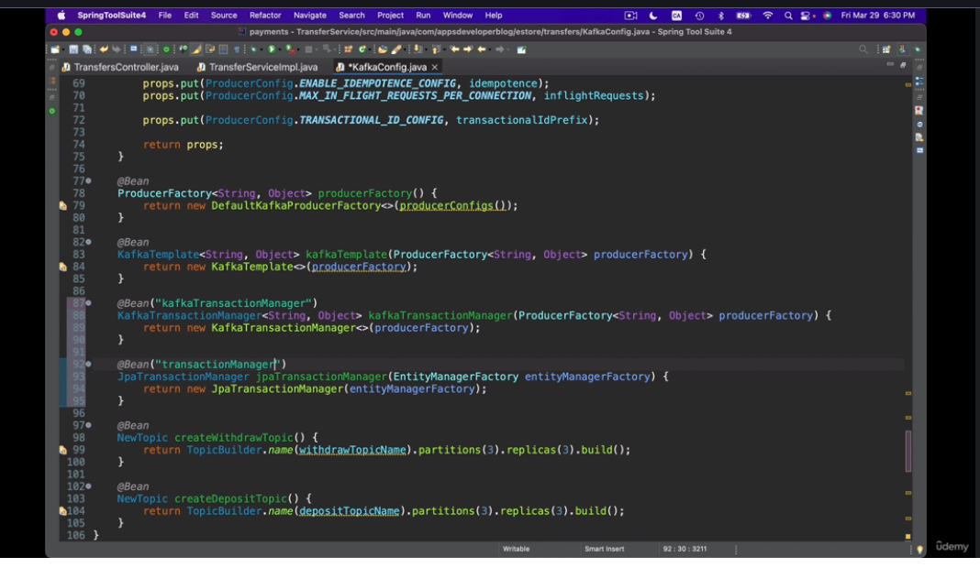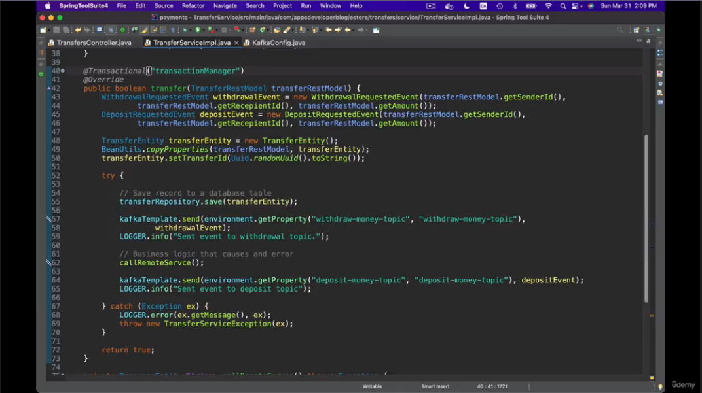
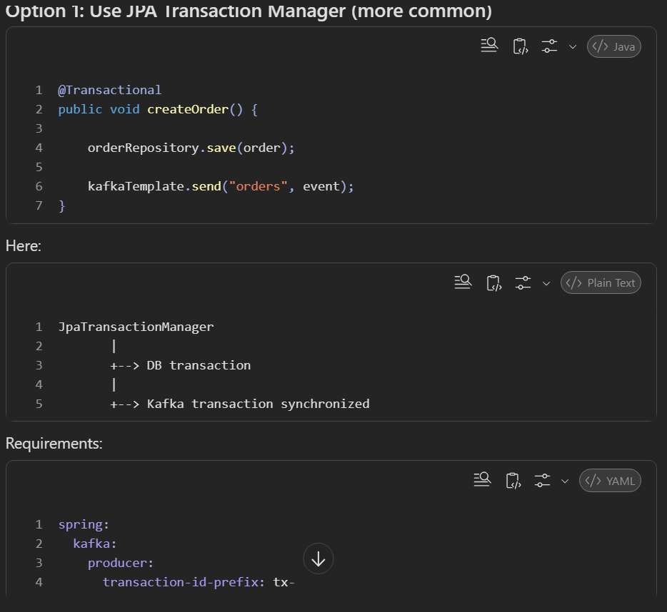
because your primary transaction is the DB transaction.
Spring can synchronize Kafka producer operations with the existing transaction.
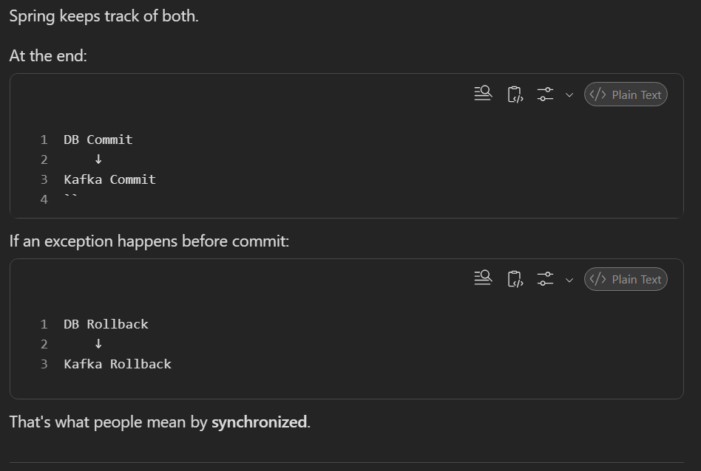
When you first learn Kafka, it looks like:
Producer ---> Kafka ---> Consumer
Simple.
Then you discover:
What if producer retries?
→ Idempotence
Then:
What if producer writes to multiple topics?
→ Transactions
Then:
What if consumer reads before commit?
→ read_committed
Then:
What if DB and Kafka both need to succeed?
→ Outbox Pattern
Then:
What if scheduler publishes twice?
→ Idempotent Consumers
Then:
What if scheduler crashes after publish but before status update?
→ Deduplication / Event IDs

Log Tracing for Kafka & JPA Transaction
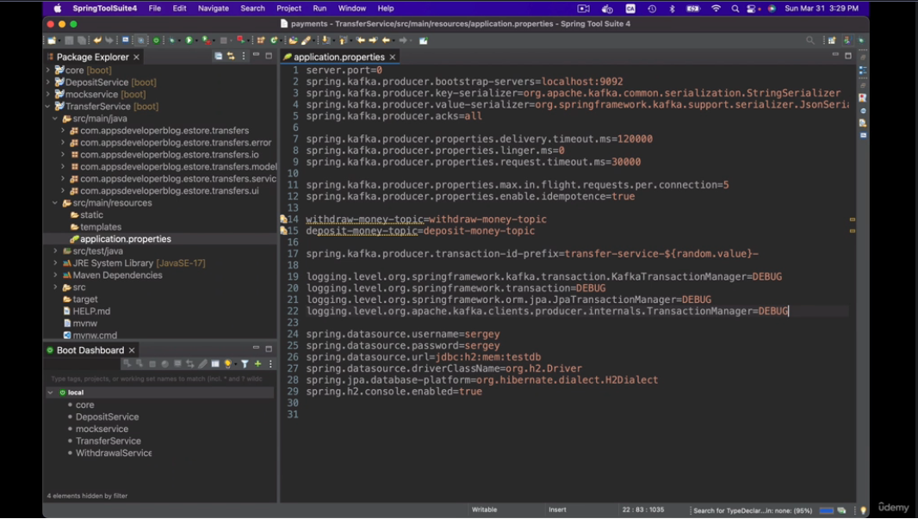
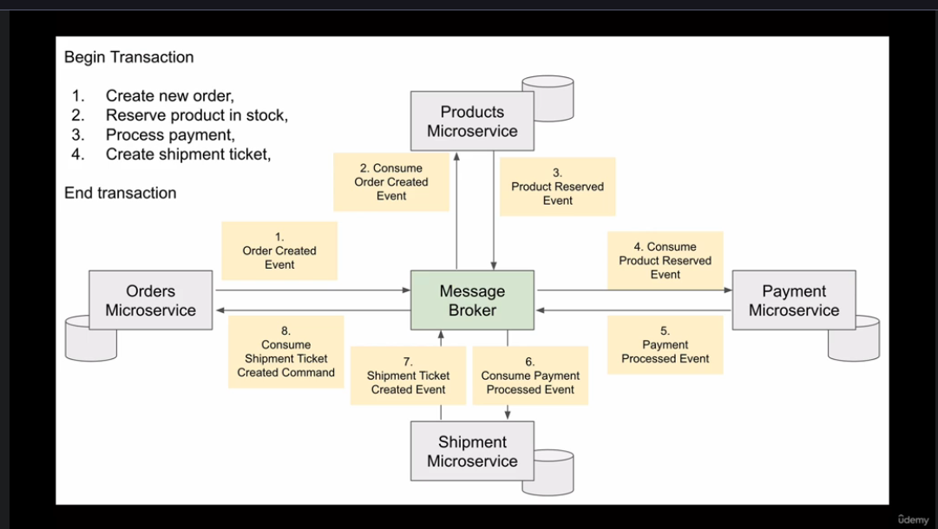
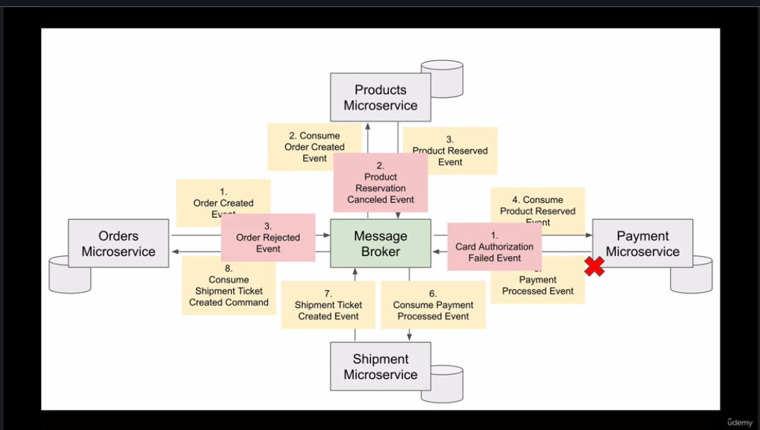
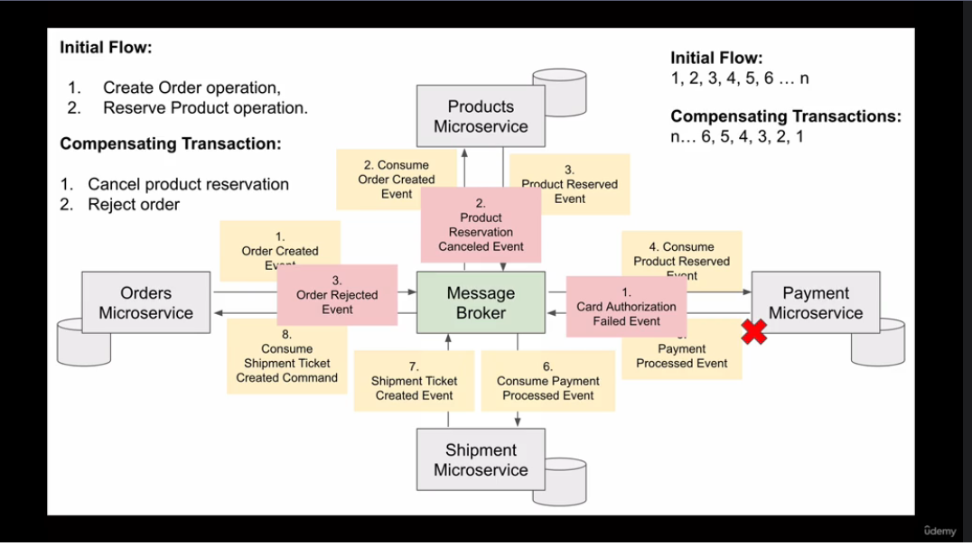

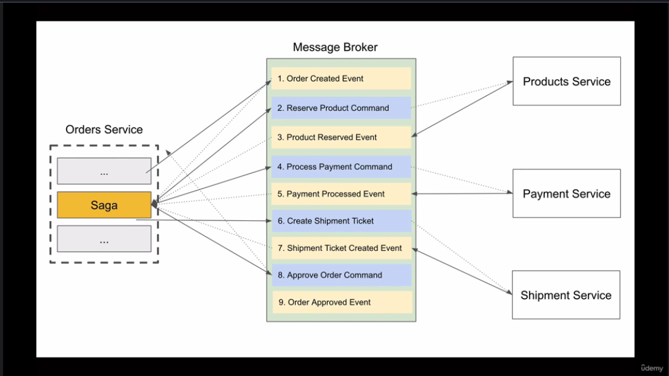
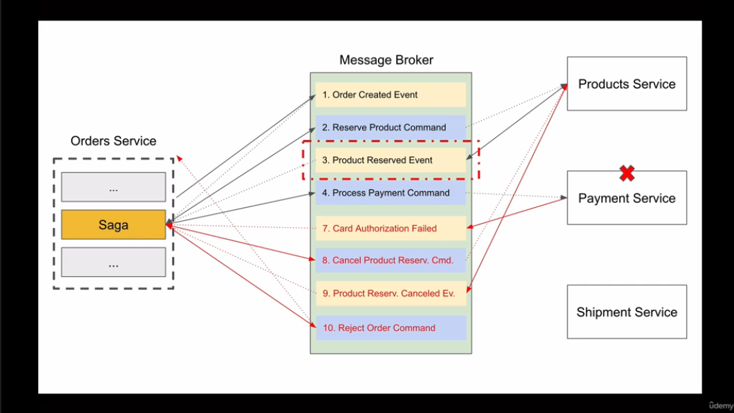
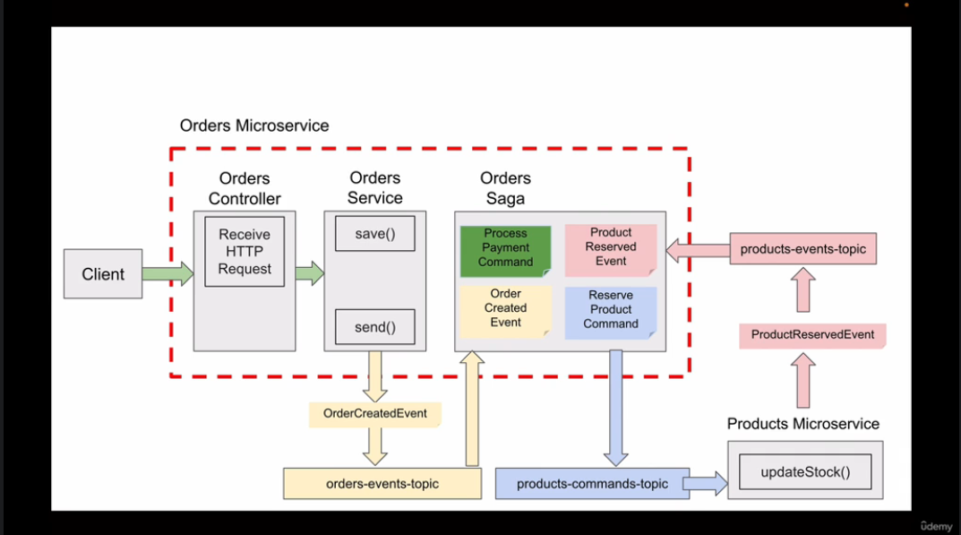
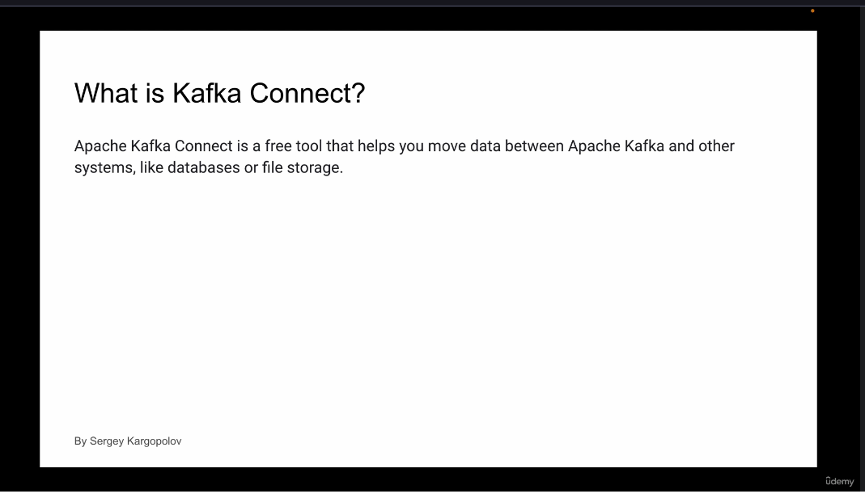
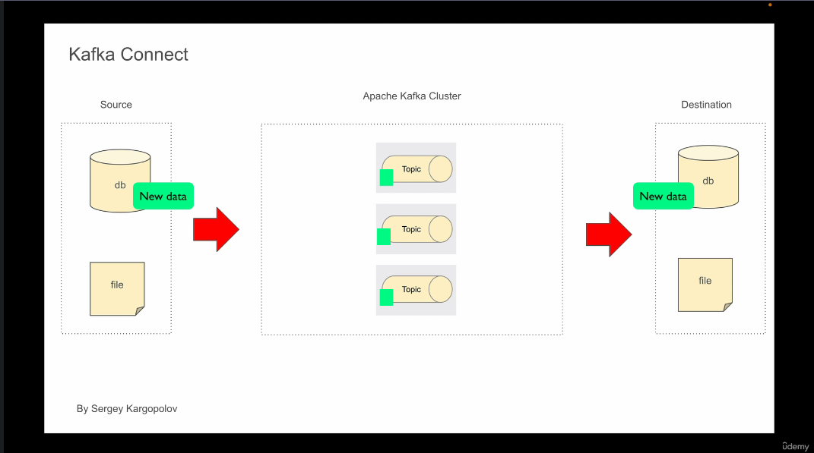
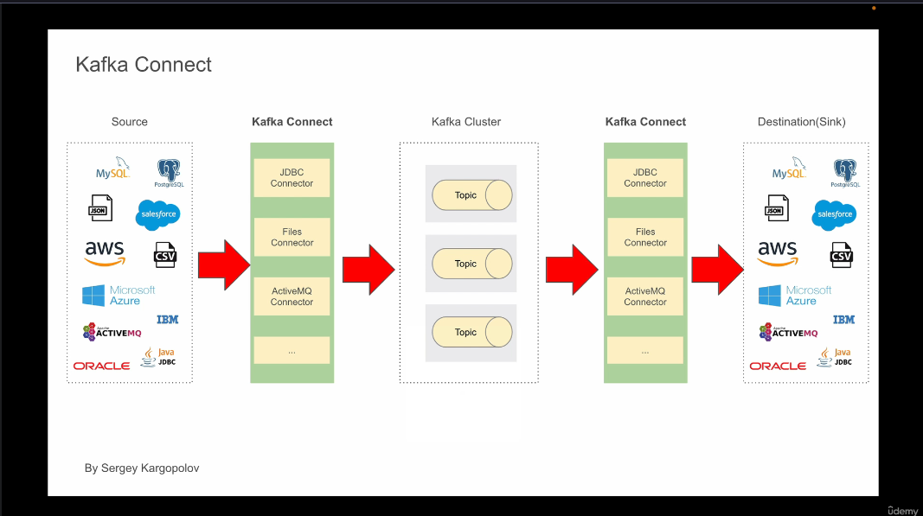
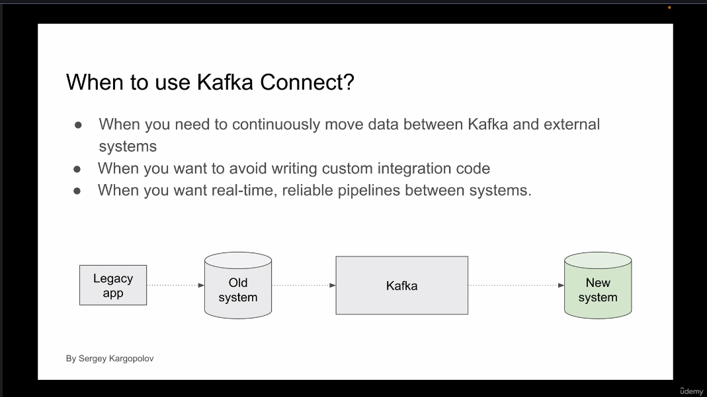

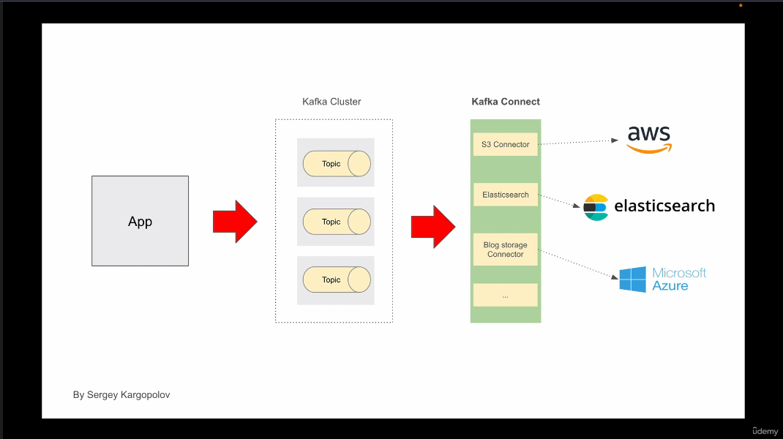

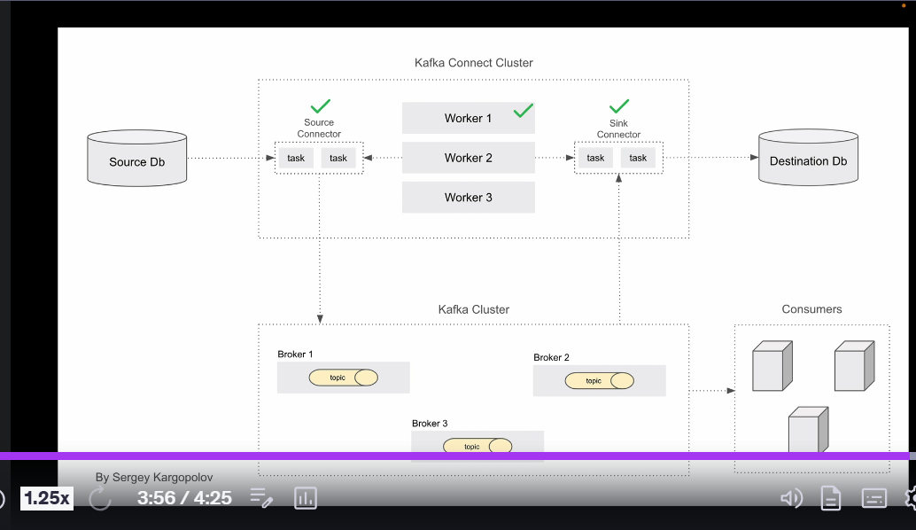
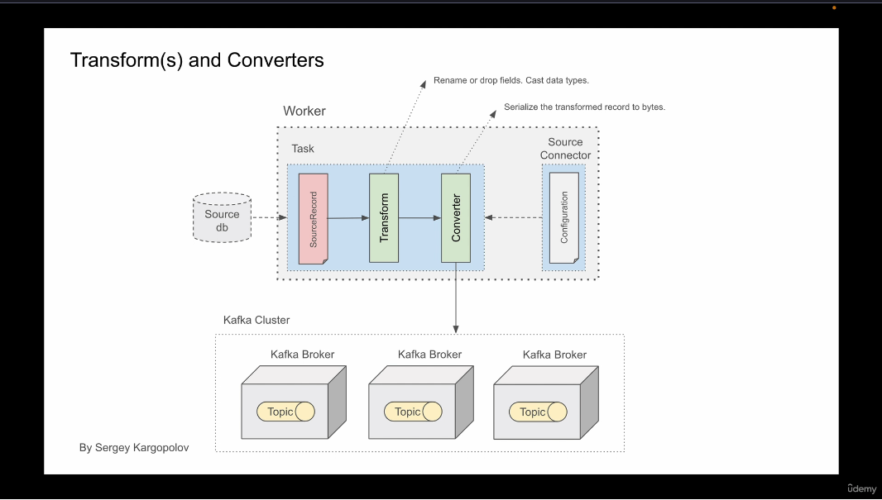

TEST CASES
